Dynamics of Disruption: How Security and Constitutional Events Shape Multidimensional Political Extremism
Amir Freund

Supplementary Information (SI) Appendix

Contents
1 Dimensions Not Included 4
1.1 Anti-Democracy 4
1.2 Anti-State 5
2 Calculation of Political Extremism Dimensions 7
2.1 Cognitive Dimension (Ideological measure) 7
2.1.1 Survey Items 7
2.1.2 CFA Model 7
2.2 Behavioral (Violence) Dimension 8
2.2.1 Survey items 8
2.2.2 CFA Model 9
2.3 Social (Intolerance) Dimension 9
2.3.1 Survey Items 9
2.3.2 CFA Model 10
3 Identification of Extremism Distribution Tail 12
4 Gauge Indices 17
4.1 Indices Definitions for Between-Populations Analysis 19
4.2 Indices Definitions for Within-Population Analysis 20
5 MANOVA Analysis 23
5.1 Prerequisites Tests 23
5.1.1 Inland Terror 23
5.1.2 Bennet Gov. Fall 23
5.1.3 Judicial Reform 24
5.1.4 Gallant Dismissal 24
5.1.5 Oct. 7th War 25
6 Robustness Tests 26
6.1 Identification of the Distribution Extreme Tail 26
6.2 Alternative Political Orientation Definition 27
6.3 Population Composition 28
6.3.1 Cognitive Dimension, Equal Balancing Model 30
6.3.2 Behavioral Dimension, Equal Balancing Model 32
6.3.3 Social Dimension, Equal Balancing Model 33
6.3.4 Cognitive Dimension, Targetted Balancing Model 35
6.3.5 Behavioral Dimension, Targetted Balancing Model 36
6.3.6 Social Dimension, Targeted Balancing Model 38
7 Extremists’ Transitions 40
7.1 Transitions per Dimension 41
7.2 Extremism Rank 2 (ER2) 42
9 Descriptive Analysis 43
9.1 Survey Measures & Dimensions 43
9.1.1 Cognitive (Ideology) Dimension 43
9.1.2 Behavioral (Violence) Dimension 44
9.1.3 Social (Intolerance) Dimension 47
9.2 Control Variables 51

Dimensions Not Included
To ensure a bias-free, context-independent conceptualization and operationalization, we opted not to include several potential dimensions, such as Anti-Democracy and Anti-State, as they are relevant only to specific types of political extremism.

Anti-Democracy
In the Western tradition, political extremism is closely linked to the exploration of non-democratic actors (Backes, 2007). The rationale for considering anti-democracy as part of our political extremism conceptualization and operationalization stems from the rise of extremism in countries experiencing democratic backsliding and the necessity of addressing far-right extremism, where anti-democracy is a defining trait. However, there is reluctance to incorporate this dimension due to a desire for a bias-free conceptualization and operationalization, as well as the complexity of managing multiple dimensions. The most substantial claim against adding it is that anti-democracy is vital to the far-right ideology and should thus be part of the ideological dimension rather than a separate one. Most definitions of "extreme right" ideology consist of five characteristics: nationalism, racism, xenophobia, a call for a strong state, and an anti-democratic attitude (Mudde, 1996, 2000). Elizabeth Carter (2018) identifies the minimal definition standard of the ideology of the right-wing parties in Europe: rejection or opposition to some or all of the values of a democracy (pluralism, equality, civil and political freedoms) and, in some cases, objection to the procedures and institutions of the democratic state. An additional claim against the addition of the anti-democracy dimension is that some right-wing ideologies that are often referred to as "radical right" do not embrace the whole extreme right ideology and support democracy.
In contrast to the "extreme right," the "radical right" aims to maintain democracy but to replace the ruling elites. Having a democratic dimension will bias the assessment of radical right groups. There are right-wing groups that support democracy and thus justify the exclusion of a democracy dimension from the political extremism conceptualization and operationalization. The anti-Islamic far-right in Europe builds on an ideological duality: the old legacy of hostility towards Muslims combined with modern gender norms and other liberal positions (Berntzen, 2018). The Cultural Nationalists movement, part of the Nordic far right, opposes Muslim immigration and social liberalism, claiming that Islam poses the greatest threat to the cultural integrity of the national people. Yet, most operate in democratic political parties (Teitelbaum, 2017).
Based on the above, we suggest that opposition to democracy should be an ideological measure when addressing far-right extremism.

Anti-State
In recent years, global anti-state and anti-government mobilizations have led to the growth of extremist groups and movements in the United States and worldwide (Robinson et al., 2023). The January 6, 2021, attack on the US Capitol illustrates the ability of such movements to orchestrate and execute violent assaults. According to the White House, anti-government or anti-authority extremists pose one of the highest threats in the USA (The White House, 2021).
Anti-state or Anti-Government extremism primarily and consistently opposes the government, the state, its institutions, and elected politicians. We focus on what Jackson (2022) defined as 'ideological anti-government extremism' that broadly opposes the government rather than specific issues that are part of the government's stance. In ideological anti-government extremism, no change in policy will satisfy the extremists. Modern manifestations of anti-state extremism are evident in both the far-left (anarchist and Antifa movements) and the far-right (militia groups and Sovereign Citizens movements), which have yielded the most influential anti-government movements in recent years (Bjørgo & Braddock, 2022). The National Consortium for the Study of Terrorism and Responses to Terrorism—better known as START (2021) identifies anti-state extremism as an ideological sub-category of far-right and far-left ideologies. Jackson (2022) claims that anti-government extremism should only refer to far-right extremists. The FBI identified it as a separate political extremism category, distinguishing it from ethnic extremism, animal rights/environmental extremism, and abortion-related extremism.
Since Anti-state extremism is not a standard characteristic of all types of political extremism, we opted not to include it as a separate dimension, but rather to recommend incorporating it into the ideological dimension in research projects that address anti-government, right-wing, or anarchist extremism.

Calculation of Political Extremism Dimensions

Cognitive Dimension (Ideological measure)

Survey Items
The ideological dimension (pe_ideology) is calculated by 'folding' the resulting CFA continuous scale of 1 to 7. When folding, we are essentially measuring distance from the midpoint (4 in a 1-7 scale). We first perform a CFA, then fold the resulting factor scores. After folding, we rescale to the standard 1-7 scale.
Table 1: Cognitive Dimension (Ideology) Survey Items
Rate your agreement with the following statements on a scale of 1-7, where 7 = strongly agree and 1 = strongly disagree.
Survey Item | Survey Text (originally in Hebrew) | Waves | Reverse
peace_1 | Israel must reach a two-state peace agreement with the Palestinians | 1-6 | R
annex_1 | Israel should annex the settlement areas in Judea and Samaria | 2-5
demo_state_3 | I prefer the idea of a complete Land of Israel to the state's democratic nature. | 2-5
Items marked by R were reversed to keep the same contextual direction as the other items.

CFA Model
Latent.var | Group | CFI | TLI | RMSEA | SRMR | Cronbach | Alpha
pe_ideology | Waves  2-last | 1 | 1 | 0 | 2.27e-08 | Acceptable reliability | 0.74
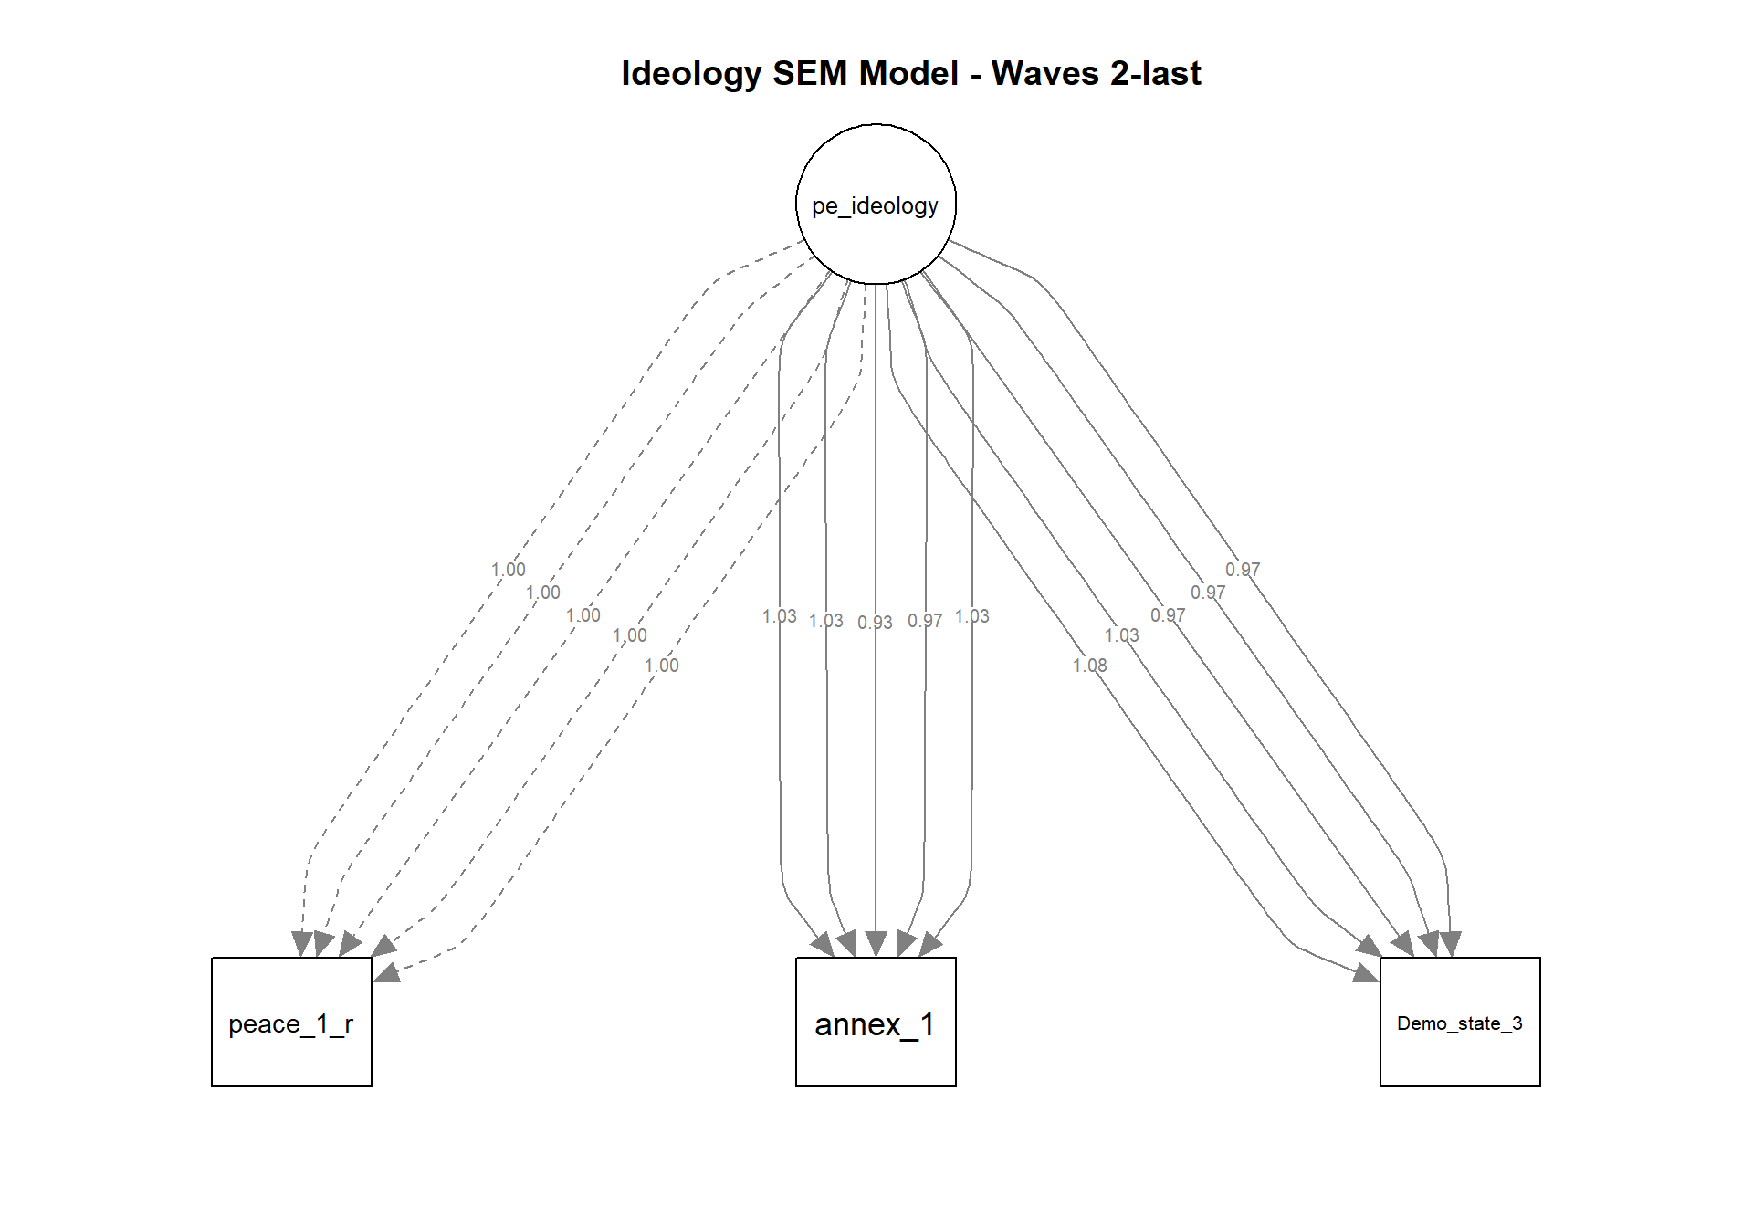

Behavioral (Violence) Dimension

Survey items
Rate your agreement with the following statements on a scale of 1-7, where 7 = strongly agree and 1 = strongly disagree.
Survey Item | Survey Text (originally in Hebrew) | Waves | Reverse
poli_violence1_1 | There are situations where there is no choice, and even weapons must be used to prevent the government from implementing its policy. | 1-6
poli_violence1_2 | When a political disaster is looming, and all means of protest have been exhausted to no avail, physically harming politicians may be forgivable. | 1-6
poli_violence1_3 | In the Israeli reality, violent struggle may sometimes be justified to achieve political gains (against the government). | 1-6
poli_violence1_4 | Sending threats and hate mail to public figures may sometimes be necessary to end a dangerous policy. | 2-6
activism__3 | Damage to public property and equipment by public employees or security forces | 1-6
activism__4 | Use of physical force against public servants or security forces | 1-6
tolerance_19 | Sometimes there is no choice but to use physical force against ______ to prevent them from advancing their interests. | 1-6
tolerance_26 | We must forcibly evict _______ from the common space. | 2-6
Items marked by R were reversed to keep the same contextual direction as the other items.

CFA Model
Latent.var | Group | CFI | TLI | RMSEA | SRMR | Cronbach | Alpha
pe_violence | Waves  2-last | 0.67 | 0.53 | 0.26 | 0.12 | Acceptable reliability | 0.78

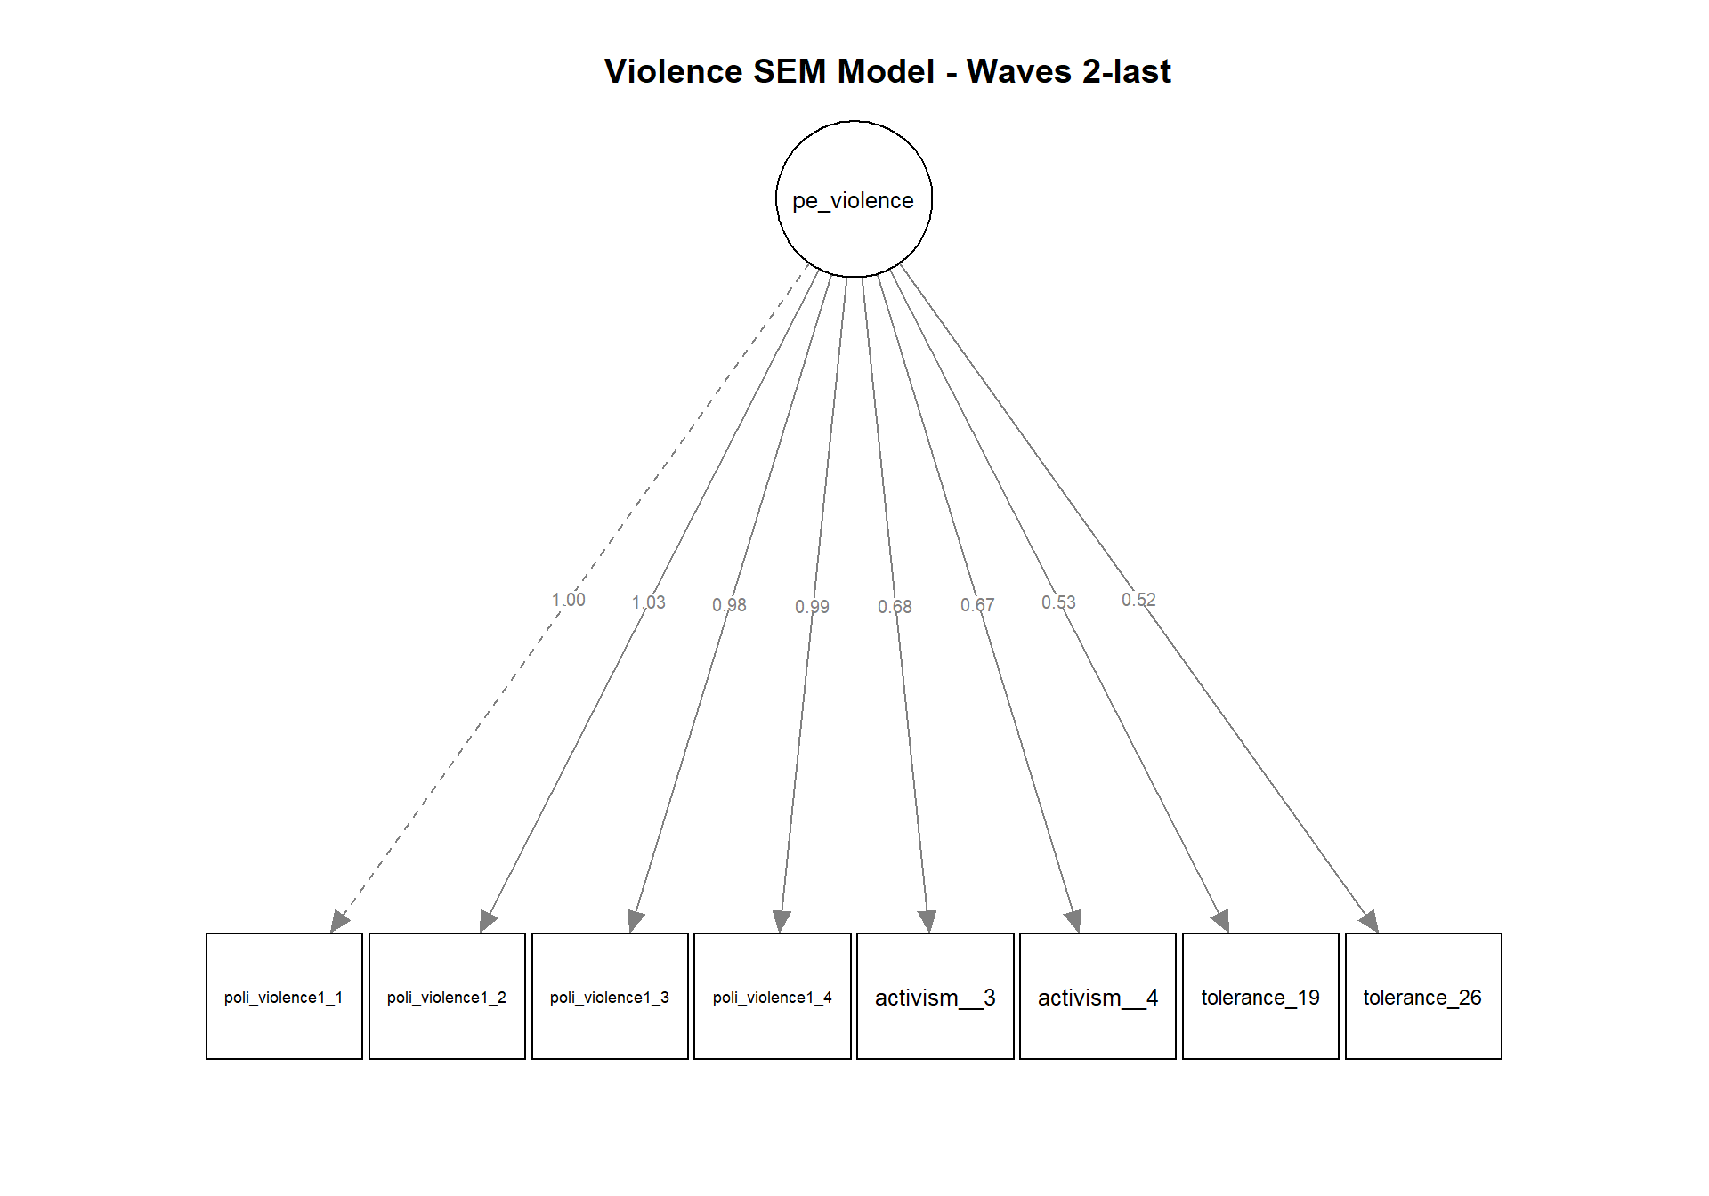

Social (Intolerance) Dimension

Survey Items
Rate your agreement with the following statements on a scale of 1-7, where 7 = strongly agree and 1 = strongly disagree.
Survey Item | Survey Text (originally in Hebrew) | Waves | Reverse
tolerance_1 | I agree that ______ will be my supervisor at work. | 1-6 | R
tolerance_2 | I agree to host ______ in my home under social circumstances. | 1-6 | R
tolerance_3 | I agree that my son or daughter will have a romantic relationship with ______ | 1-6 | R
tolerance_5 | I am willing to read opinion pieces by ______ | 1-6 | R
tolerance_9 | ______ should be banned from serving as prime ministers in Israel | 1-6
tolerance_10 | ______ should not be allowed to serve as members of the Knesset | 1-6
tolerance_11 | ______ should not be allowed to teach in public schools | 1-6
tolerance_13 | ____ should be allowed to hold demonstrations | 1-6 | R
tolerance_15 | Monitoring of the telephones of ______ should be allowed | 1-6
tolerance_16 | ______ should be banned from teaching at university | 1-6
tolerance_18 | ______ should be denied the right to express their worldview publicly | 1-6
tolerance_20 | ______ should be stripped of their citizenship | 1-6
Items marked by R were reversed to keep the same contextual direction as the other items.

CFA Model
Latent.var | Group | CFI | TLI | RMSEA | SRMR | Cronbach | Alpha
pe_intolerance | All Waves | 0.81 | 0.77 | 0.16 | 0.07 | Excellent reliability | 0.93

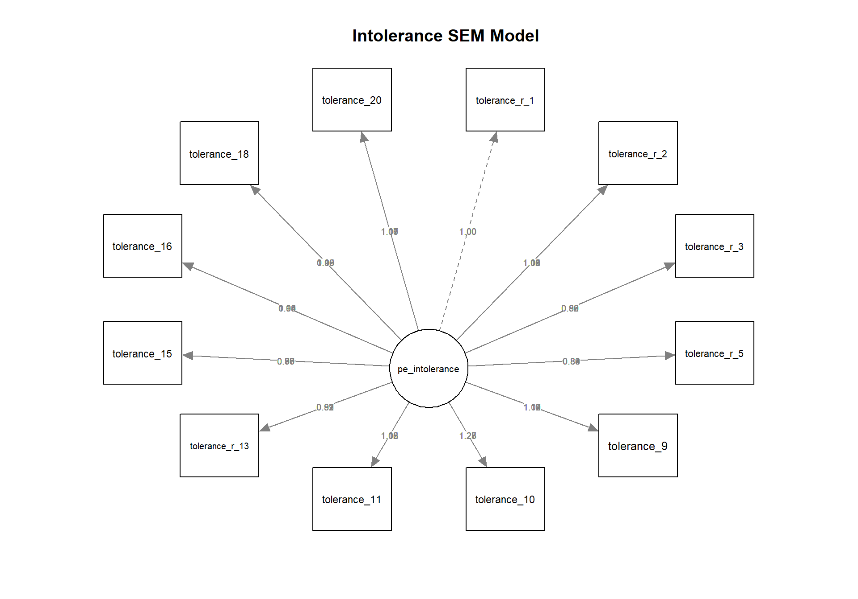

Identification of Extremism Distribution Tail
A primary challenge in this project involves establishing a threshold that accurately captures the more extreme segments of the population without including moderate respondents or sacrificing the statistical power necessary for subsequent analysis. To address this, the current study employs a tailored thresholding strategy designed to navigate the unique statistical properties of extremism data across six longitudinal waves.
The study evaluates the extreme tail segment for each dimension independently using a robust statistical approach: the Median plus a multiplier of the Median Absolute Deviation (Median + K * MAD). Unlike mean-based thresholds or simple quantiles, this method offers greater resilience against the influence of outliers, which are inherent to radicalization studies. While the quantile-based approach provides a straightforward identification of the top percentage of a population, it fails to account for the distribution's actual dispersion or shape, potentially misclassifying respondents if the distribution in a specific wave is less skewed. Using the MAD, the threshold adapts to the particular variance of each dimension and wave, ensuring that the identified "extreme" population is statistically distinct from the general public's central tendency.
Configuring the K factor is a critical step in this methodology. In this research, we selected K = 1.5 as a calibrated baseline that consistently meets the requirements for a minimum sample size of 80-100 respondents and a granularity of at least 4-5 unique values. However, the selection of K is not a rigid requirement of the model but rather a flexible parameter that must be tuned to the specific dataset at hand. This flexibility allows the methodology to serve as a novel gauge of political extremism applicable across diverse contexts. Future researchers using this approach should conduct a similar sensitivity analysis to determine the optimal K for their data.

A visual inspection of the population distributions across the cognitive, behavioral, and social dimensions further underscores the need for a robust thresholding method. The density plots show that while some dimensions, such as intolerance, exhibit a more spread-out distribution, others, such as the behavioral dimension (violence), are heavily skewed toward the lower end of the scale. This skewness highlights the limitations of fixed-quantile-based approaches, which may set a threshold deep within a densely populated region of the distribution rather than isolating the true mathematical tail. By overlaying the thresholds for the Quantile (85%), Median + 1.5 MAD, and Median + 1.5 Qn methods, the visual data confirms that the Median + MAD approach consistently captures the "elbow" of the distribution, where the frequency of responses begins to flatten. This sensitivity to the unique shape and density of each wave is critical for maintaining a theoretically valid definition of extremism, especially as the distribution of the general population shifts in response to a major destabilizing event.
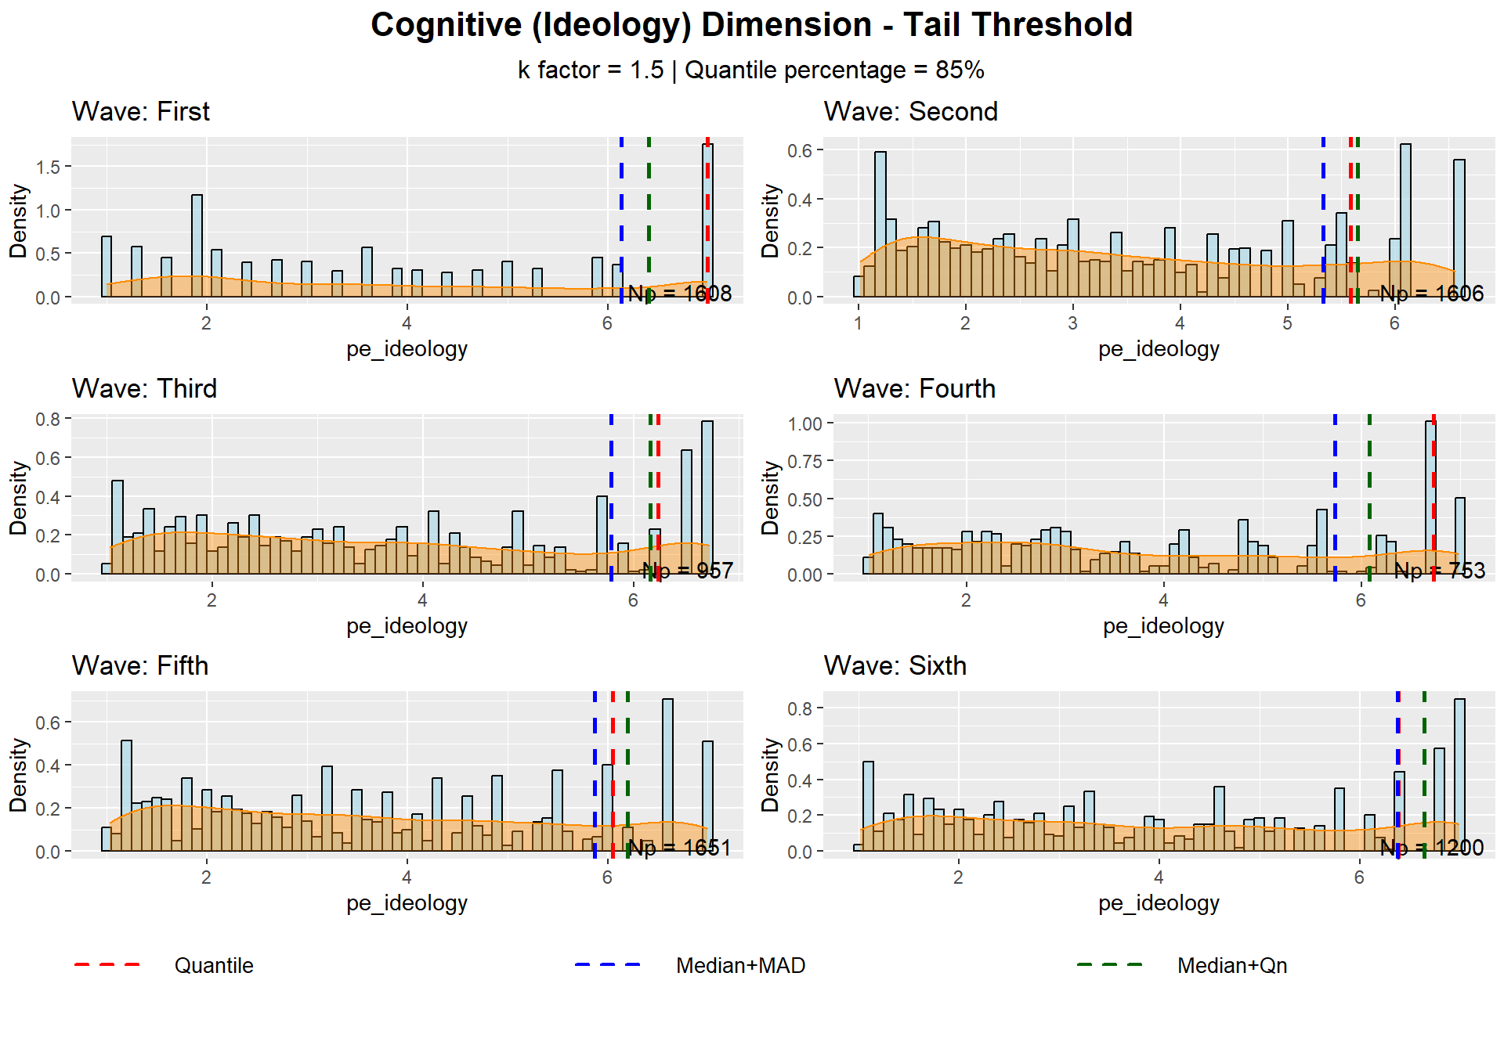
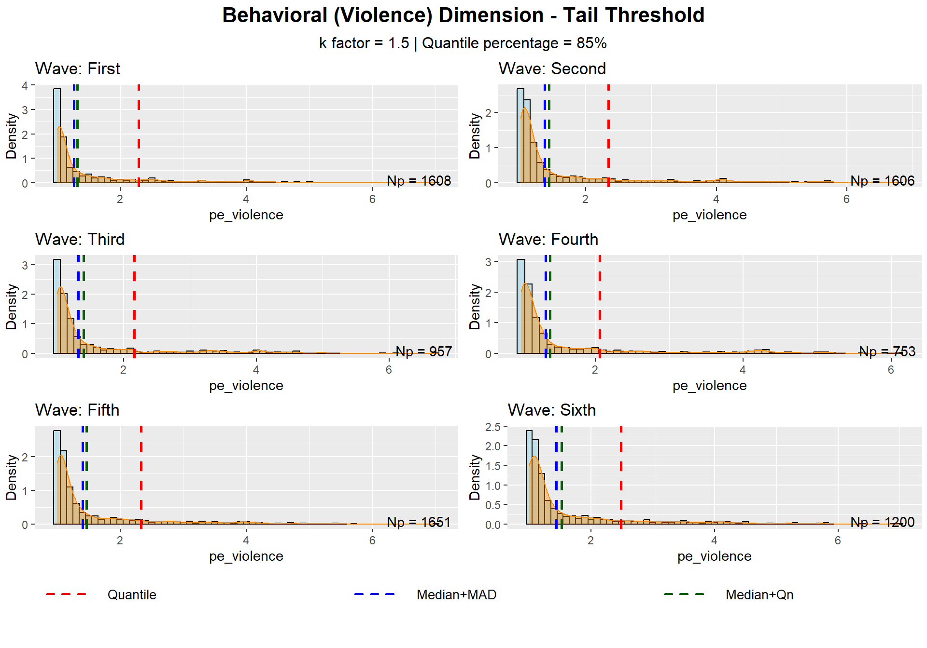
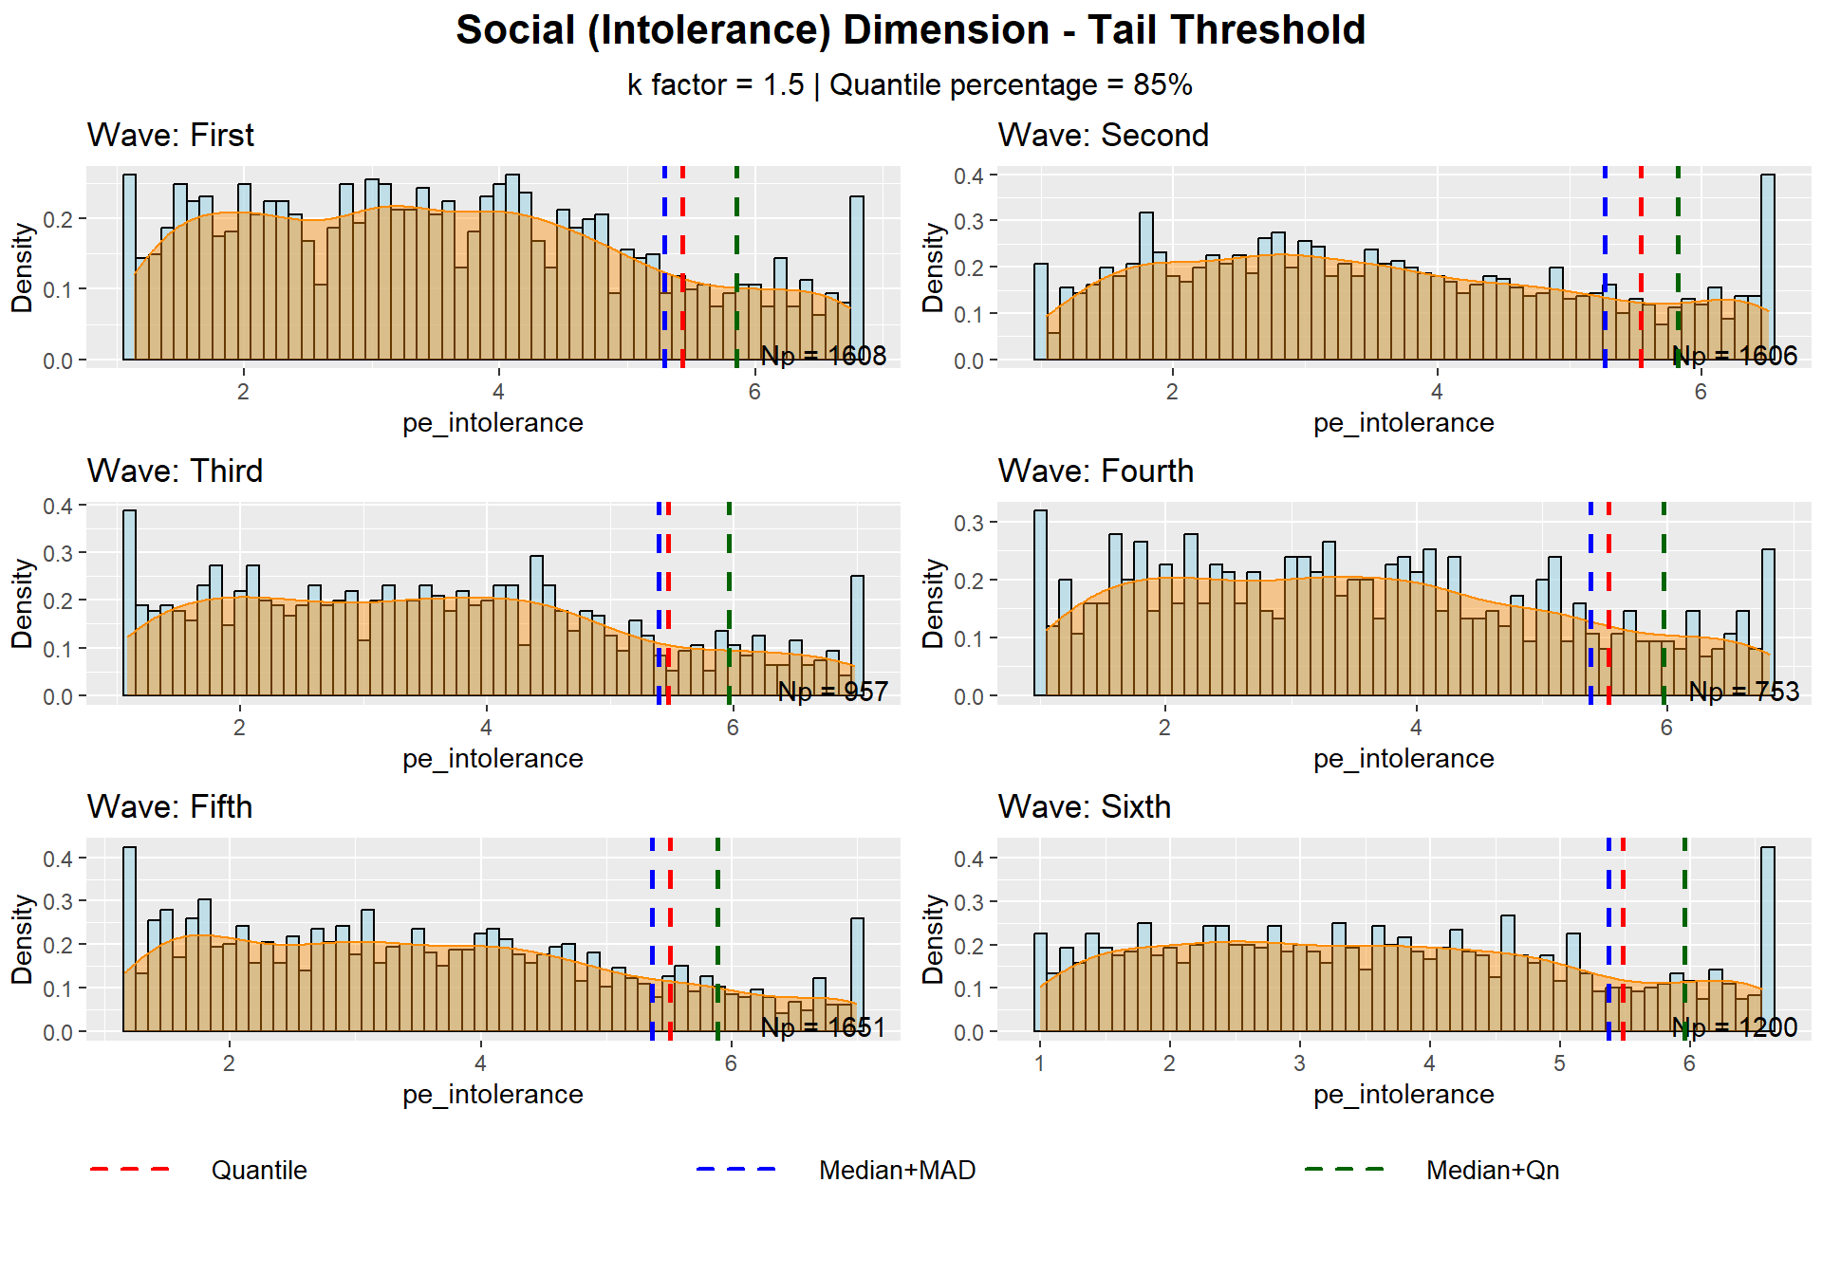
To validate the consistency of the Median + 1.5 * MAD approach, a rigorous suitability assessment was conducted for each of the three extremism dimensions across all six waves. The primary metrics for this evaluation included the total tail size (N), the percentage of the population captured within the tail, the mean level of extremism within that subgroup, and the number of unique values as a measure of granularity. According to the data summarized in the tables below, the behavioral (violence) and social (intolerance) dimensions demonstrated high suitability in every instance, consistently maintaining tail sizes well above the 100-sample minimum and providing substantial unique values for differentiation. The cognitive dimension (ideology) also proved robust, although the number of unique values in waves one and six was marginal.
Table 2: Cognitive (Ideology) Dimension - Tail Identification Assessment
K Factor: 1.5 | Waves: 6
Metric | First | Second | Third | Fourth | Fifth | Sixth
Sample Size | 1608 | 1606 | 957 | 753 | 1651 | 1200
Tail Size | 341 | 343 | 176 | 155 | 293 | 224
Tail % | 21.2 | 21.4 | 18.4 | 20.6 | 17.7 | 18.7
Tail Mean | 6.852 | 6.006 | 6.505 | 6.651 | 6.568 | 6.806
Unique Values | 4 | 11 | 7 | 9 | 7 | 4

Table 3: Behavioral (Violence) Dimension - Tail identification Assessment
K Factor: 1.5 | Waves: 6
Metric | First | Second | Third | Fourth | Fifth | Sixth
Sample Size | 1608 | 1606 | 957 | 753 | 1651 | 1200
Tail Size | 578 | 504 | 307 | 225 | 520 | 393
Tail % | 35.9 | 31.4 | 32.1 | 29.9 | 31.5 | 32.8
Tail Mean | 2.383 | 2.722 | 2.573 | 2.638 | 2.635 | 2.707
Unique Values | 438 | 468 | 294 | 219 | 497 | 378

Table 4: Social (Intolerance) Dimension - Tail identification Assessment
K Factor: 1.5 | Waves: 6
Metric | First | Second | Third | Fourth | Fifth | Sixth
Sample Size | 1608 | 1606 | 957 | 753 | 1651 | 1200
Tail Size | 544 | 470 | 279 | 208 | 487 | 356
Tail % | 33.8 | 29.3 | 29.2 | 27.6 | 29.5 | 29.7
Tail Mean | 2.452 | 2.818 | 2.695 | 2.743 | 2.716 | 2.835
Unique Values | 429 | 438 | 272 | 204 | 467 | 345

Gauge Indices
The gauge enables two distinct analytical approaches for examining political extremism. The first is the Between-Populations analysis, which targets a macro-level comparison of entire populations, such as different countries. This approach involves comparing both absolute and relative gauge indices for each population. The second strategy is the Within-Population Analysis, which examines levels of extremism across communities within a single population. The relative indices are computed using the overall population's central tendency, rather than that of the specific community. By referencing the overall population, relative indices directly indicate the "contribution" to the entire population's political extremism level, rather than just the internal variation.
Figure 1 below presents a three-dimensional visualization of the political extremism gauge framework. The cuboid structure represents the measurement space for the three continuous extremism dimensions: Cognitive, Behavioral, and Social. The Normative Point (NP) indicates the central tendency for each dimension, while the Extremism Point (EP) establishes the threshold for identifying the more extremist population segment. Figure 1: Political Extremism Gauge
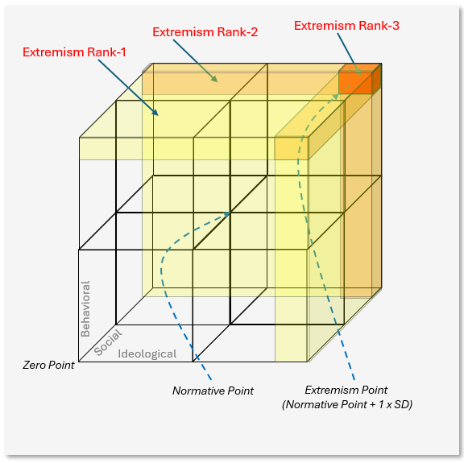
The gauge generates three hierarchical rankings of extremism based on geometric regions in this space. Extremism Rank-1 (ER1) captures the percentage of the population exceeding the EP threshold in at least one dimension, visualized by the yellow-shaded planes. Extremism rank-2 (ER2) represents individuals who surpass the EP in at least 2 dimensions, as shown by the orange-colored intersections. Extremism Rank-3 (ER3) identifies the most comprehensive extremists who exceed the EP across all three dimensions simultaneously, depicted by the red cuboid positioned at the gauge's furthest corner.

Indices Definitions for Between-Populations Analysis
The Between-Population indices aim to assess the political extremism of large population groups, mainly countries, each with distinct cultures, political environments, etc. These indices are targeted to support comparative analysis between them.
The Normative Point (NP) represents the median score for each dimension. The NP is calculated for each population group p. The first letter in the index name is set based on the dimension: Cognitive (CNP), Behavioral (BNP), and Social (SNP).
$$CNP_{p}=\text{Median}\left(C_{p}\right)$$
$$BNP_{p}=\text{Median}\left(B_{p}\right)$$
$$SNP_{p}=\text{Median}\left(S_{p}\right)$$
The Extremism Point (EP) is calculated by adding 1.5*MAD of the population group p to the normative points. The overall extremism point is calculated using the RMS function.
$$CEP_{p}=CNP+1.5*\text{MAD}\left(C_{p}\right)$$
$$BEP_{p}=BNP+1.5*\text{MAD}\left(B_{p}\right)$$
$$SEP_{p}=SNP+1.5*\text{MAD}\left(S_{p}\right)$$
The Extremism Level (EL) indicates the percentage of population members with values above the Extremism Point in each dimension. M_{p}​ is the total number of individuals in population p. X_{p,i} is the score of individual i in population p.
$$CEL_{p}=\frac{100\sum_{i=1}^{M_{p}}{\left[C_{p,i}>CEP_{p}\right]}}{M_{p}}$$
$$BEL_{p}=\frac{100\sum_{i=1}^{M_{p}}{\left[B_{p,i}>BEP_{p}\right]}}{M_{p}}$$
$$SEL_{p}=\frac{100\sum_{i=1}^{M_{p}}{\left[S_{p,i}>SEP_{p}\right]}}{M_{p}}$$
Extermism Intensity (EIN) indicates the mean of population members with values above the Extremism Point in each dimension. M_{p}​ is the total number of individuals in population p. X_{p,i} is the score of individual i in population p.
$$CEIN_{p}=\frac{\sum_{i=1}^{Mp}{\left[C_{p,i} | C_{p,i}>CEP_{p}\right]}}{\sum_{i=1}^{Mp}{\left[C_{p,i}>CEP_{p}\right]}}$$
$$BEIN_{p}=\frac{\sum_{i=1}^{Mp}{\left[B_{p,i} | B_{p,i}>BEP_{p}\right]}}{\sum_{i=1}^{Mp}{\left[B_{p,i}>BEP_{p}\right]}}$$
$$SEIN_{p}=\frac{\sum_{i=1}^{Mp}{\left[S_{p,i} | S_{p,i}>SEP_{p}\right]}}{\sum_{i=1}^{Mp}{\left[S_{p,i}>SEP_{p}\right]}}$$
The Extremism Rank represents the percentage of population members with higher rankings than the Extremism Point in at least one, two, or three dimensions. M_{p}​ is the total number of individuals in population p. X_{p,i,j}​ is the score of individual i in population p on dimension j. EP_{p,j}​ is the Extremism Point for population p on dimension j.
$$ER1p=\frac{100\sum_{i=1}^{M_{p}}{\left[\sum_{j=1}^{3}{\left[X_{p,i,j}>EP_{p,j}\right]}≥1\right]}}{M_{p}}$$
$$ER2p=\frac{100\sum_{i=1}^{M_{p}}{\left[\sum_{j=1}^{3}{\left[X_{p,i,j}>EP_{p,j}\right]}≥2\right]}}{M_{p}}$$
$$ER3p=\frac{100\sum_{i=1}^{M_{p}}{\left[\sum_{j=1}^{3}{\left[X_{p,i,j}>EP_{p,j}\right]}≥3\right]}}{M_{p}}$$

Indices Definitions for Within-Population Analysis
The Within-Population indices aim to assess political extremism within a population. Examples can include politically or religiously oriented groups within a country. The Within-Population is not based on using the community EP (Although we calculate it), but rather relates to the 'mother' population EP. These relative indices support comparative analysis between communities and identify each community's overall contribution to the "mother" population's extremism level.
The Normative Point (NP) is calculated for each community c within a population group p. The first letter in the index name is set based on the dimension: Cognitive (CNP), Behavioral (BNP), and Social (SNP).
$$CNP_{c}=\text{Median}\left(C_{c}\right)$$
$$BNP_{c}=\text{Median}\left(B_{c}\right)$$
$$SNP_{c}=\text{Median}\left(S_{c}\right)$$
The Extremism Point (EP) is calculated by adding 1.5*MAD of the community to the normative points within community c.
$$CEP_{c}=CNP+1.5*\text{MAD}\left(C_{c}\right)$$
$$BEP_{c}=BNP+1.5*\text{MAD}\left(B_{c}\right)$$
$$SEP_{c}=SNP+1.5*\text{MAD}\left(S_{c}\right)$$
The Extremism Level indicates the percentage of community members with values above the population's Extremism Point in each dimension. M_{c}​ is the total number of individuals in community c. X_{c,i} is the dimension score of individual i in community c ( X is either C - cognitive dimension, B - Behavioral dimension, or S - Social dimension). XEP_{p} is the extremism point of population p ( X is either C, B, or S).
$$CEL_{c}=\frac{100\sum_{i=1}^{M_{c}}{\left[C_{c,i}>CEP_{p}\right]}}{M_{c}}$$
$$BEL_{c}=\frac{100\sum_{i=1}^{M_{c}}{\left[B_{c,i}>BEP_{p}\right]}}{M_{c}}$$
$$SEL_{c}=\frac{100\sum_{i=1}^{M_{c}}{\left[S_{c,i}>SEP_{p}\right]}}{M_{c}}$$
Extermism Intensity (EIN) indicates the mean of community members with values above the Extremism Point of the 'mother' population in each dimension. Mc is the total number of individuals in community c. X_{c,i} is the score of individual i in community c ( X is either C - cognitive dimension, B - Behavioral dimension, or S - Social dimension). XEP_{p} is the extremism point of population p ( X is either C, B, or S).
$$CEIN_{c}=\frac{\sum_{i=1}^{Mc}{\left[C_{c,i} | C_{c,i}>CEP_{p}\right]}}{\sum_{i=1}^{Mc}{\left[C_{c,i}>CEP_{p}\right]}}$$
$$BEIN_{c}=\frac{\sum_{i=1}^{Mc}{\left[B_{p,i} | B_{c,i}>BEP_{p}\right]}}{\sum_{i=1}^{Mc}{\left[B_{c,i}>BEP_{p}\right]}}$$
$$SEIN_{c}=\frac{\sum_{i=1}^{Mc}{\left[S_{c,i} | S_{c,i}>SEP_{p}\right]}}{\sum_{i=1}^{Mc}{\left[S_{c,i}>SEP_{p}\right]}}$$
The Extremism Rank represents the percentage of group members with higher rankings than the Extremism Point in at least one, two, or three dimensions. M_{p}​ is the total number of individuals in population p. X_{p,i,j}​ is the score of individual i in population p on dimension j. EP_{p,j}​ is the Extremism Point for population p on dimension j.
$$ER1c=\frac{100\sum_{i=1}^{M_{c}}{\left[\sum_{j=1}^{3}{\left[X_{c,i,j}>EP_{p,j}\right]}≥1\right]}}{M_{c}}$$
$$ER2c=\frac{100\sum_{i=1}^{M_{c}}{\left[\sum_{j=1}^{3}{\left[X_{c,i,j}>EP_{p,j}\right]}≥2\right]}}{M_{c}}$$
$$ER3c=\frac{100\sum_{i=1}^{M_{c}}{\left[\sum_{j=1}^{3}{\left[X_{c,i,j}>EP_{p,j}\right]}≥3\right]}}{M_{c}}$$

MANOVA Analysis

ANOVA Results
ANOVA Results Across Destabilizing Events
Extremism Dimension: Ideology
Variable | Inland Terror | Bennet Gov. Fall | Judicial Reform § | Gallant Dismissal | Oct. 7th War
Destabilizing Event | 23.160***  (-0.154) | 8.961**  (+0.282) | 0.712  (+0.033) | 0.270  (-0.090) | 8.278**  (+0.284)
Political Orientation | 93.900*** | 164.251*** | 135.200*** | 125.062*** | 128.621***
Religiosity | 14.421*** | 14.130*** | 9.280*** | 14.828*** | 13.490***
Education | 2.651* | 3.425** | 3.470** | 2.840* | 2.218*
Gender | 65.998*** | 60.906*** | 37.354*** | 58.401*** | 58.468***
Age Group | 7.252*** | 14.031*** | 14.544*** | 10.282*** | 13.614***
Event × Political Orientation | 13.018*** | 2.745† | 0.861 | 3.962* | 2.188
Values are F-statistics with significance stars. Mean shifts (Wave 2 - Wave 1) on the 1–7 scale are provided in parentheses for event effects. *** p < .001; ** p < .01; * p < .05; † p < .10.

ANOVA Results Across Destabilizing Events
Extremism Dimension: Violence
Variable | Inland Terror | Bennet Gov. Fall | Judicial Reform § | Gallant Dismissal | Oct. 7th War
Destabilizing Event | 5.054*  (+0.033) | 1.445  (-0.038) | 0.345  (+0.089) | 0.571  (+0.014) | 2.103  (+0.118)
Political Orientation | 24.238*** | 30.251*** | 2.436† | 1.180 | 1.397
Religiosity | 3.950** | 4.130*** | 6.877*** | 4.338*** | 3.137**
Education | 3.592** | 2.376* | 1.112 | 1.264 | 1.173
Gender | 22.936*** | 21.361*** | 32.715*** | 66.609*** | 62.892***
Age Group | 11.076*** | 12.142*** | 14.515*** | 13.139*** | 12.213***
Event × Political Orientation | 3.094* | 0.147 | 4.898** | 0.427 | 3.667*
Values are F-statistics with significance stars. Mean shifts (Wave 2 - Wave 1) on the 1–7 scale are provided in parentheses for event effects. *** p < .001; ** p < .01; * p < .05; † p < .10.

ANOVA Results Across Destabilizing Events
Extremism Dimension: Intolerance
Variable | Inland Terror | Bennet Gov. Fall | Judicial Reform § | Gallant Dismissal | Oct. 7th War
Destabilizing Event | 0.000  (-0.046) | 0.000  (-0.004) | 0.035  (+0.019) | 0.000  (+0.047) | 0.000  (0.000)
Political Orientation | 323.263*** | 282.553*** | 164.681*** | 187.793*** | 178.572***
Religiosity | 22.731*** | 13.004*** | 5.955*** | 7.686*** | 11.210***
Education | 8.317*** | 4.414*** | 5.845*** | 6.613*** | 8.191***
Gender | 0.754 | 0.216 | 2.128 | 0.063 | 0.002
Age Group | 18.258*** | 11.860*** | 5.491*** | 9.813*** | 8.633***
Event × Political Orientation | 4.815** | 1.302 | 0.086 | 2.875† | 0.124
Values are F-statistics with significance stars. Mean shifts (Wave 2 - Wave 1) on the 1–7 scale are provided in parentheses for event effects. *** p < .001; ** p < .01; * p < .05; † p < .10.

MANOVA Prerequisites Tests

Inland Terror
The MANOVA prerequisites assessment examined 6 key assumptions across 3 dependent variables and 3 groups, with 3214 observations. Multivariate normality was violated (Shapiro-Wilk W = 0.6431, p = 0). This is a common finding with large datasets. However, because the sample size is large (n > 200), MANOVA is robust to this violation under the Central Limit Theorem. Covariance matrix homogeneity was violated (Box's M χ² = 305.64, p = 0), which is adequately addressed by using Pillai's trace as the test statistic. Linear relationships showed some concerns (correlation range: 0.048 to 0.252), warranting careful interpretation of the results. Multicollinearity levels were acceptable (correlation matrix determinant = 9.19e-01 ). Multivariate outliers were within permissible limits (3% of cases exceeded the critical value). The sample size was adequate for robust analysis (minimum group size = 488; recommended minimum total N = 19).

Bennet Gov. Fall
The MANOVA prerequisites assessment examined 6 key assumptions across 2563 observations with 3 dependent variables and 3 groups. Multivariate normality was violated (Shapiro-Wilk W = 0.8466, p = 0). This is a common finding with large datasets. However, because the sample size is large (n > 200), MANOVA is robust to this violation under the Central Limit Theorem. Covariance matrix homogeneity was violated (Box's M χ² = 360.22, p = 0), which is adequately addressed by using Pillai's trace as the test statistic. Linear relationships among variables appeared adequate (correlation range: 0.123 to 0.255). Multicollinearity levels were acceptable (correlation matrix determinant = 9.04e-01 ). Multivariate outliers were within permissible limits (2.6% of cases exceeded the critical value). The sample size was adequate for robust analysis (minimum group size = 389; recommended minimum total N = 19).

Judicial Reform
The Repeated Measures MANOVA prerequisites assessment examined 3 key assumptions across 1506 observations from 753 subjects. The data structure is appropriate for a repeated-measures design, confirming independence among subjects. Multivariate normality was violated in at least one group, though the Repeated Measures MANOVA remains robust with an adequate number of subjects. Sphericity was not assessed as it requires three or more waves.

Gallant Dismissal
The MANOVA prerequisites assessment examined 6 key assumptions across 2404 observations with 3 dependent variables and 3 groups. Multivariate normality was violated (Shapiro-Wilk W = 0.8511, p = 0). This is a common finding with large datasets. However, because the sample size is large (n > 200), MANOVA is robust to this violation under the Central Limit Theorem. Covariance matrix homogeneity was violated (Box's M χ² = 167.75, p = 0), which is adequately addressed by using Pillai's trace as the test statistic. Linear relationships among variables appeared adequate (correlation range: 0.107 to 0.145). Multicollinearity levels were acceptable (correlation matrix determinant = 9.59e-01 ). Multivariate outliers were within permissible limits (3% of cases exceeded the critical value). The sample size was adequate for robust analysis (minimum group size = 382; recommended minimum total N = 19).

Oct. 7th War
The MANOVA prerequisites assessment examined 6 key assumptions across 2851 observations with 3 dependent variables and 3 groups. Multivariate normality was violated (Shapiro-Wilk W = 0.8548, p = 0). This is a common finding with large datasets. However, because the sample size is large (n > 200), MANOVA is robust to this violation under the Central Limit Theorem. Covariance matrix homogeneity was violated (Box's M χ² = 174.64, p = 0), which is adequately addressed by using Pillai's trace as the test statistic. Linear relationships among variables appeared adequate (correlations range: 0.101 to 0.128 ). Multicollinearity levels were acceptable (correlation matrix determinant = 9.63e-01 ). Multivariate outliers were within permissible limits (2.9% of cases exceeded the critical value). The sample size was adequate for robust analysis (minimum group size = 427; recommended minimum total N = 19).

Robustness Tests

Identification of the Distribution Extreme Tail
A Latent Profile Analysis (LPA) revealed five distinct profiles along the dimensions of political extremism, achieving a strong classification quality with an entropy value of 0.754. Table 4 summarizes these findings, showing the average extremism scores for each profile dimension in the Cognitive, Behavioral, and Social columns. Profile 3 emerged as the most extremist group, followed by Profile 1 as the second-most extremist, based on their dimension means. The ER1, ER2, and ER3 columns indicate what percentage of each profile's members fall into extremist-ranked categories according to these three indices.
The analysis indicates a robust relationship between profile membership and extremist classification. Notably, all members of Profile 3 and 88.2% of Profile 1 members qualify for the ER1 extremist category, substantially higher than the other three profiles (31.5%, 42.3%, and 28.8%, respectively). This distinction becomes even more pronounced for ER2 classification: Profile 3 contains 32% extremists, while Profile 1 contains 26.1%. The remaining profiles show much lower rates (3.8%, 6.5%, and 0.9%). For the most restrictive ER3 category, only Profiles 3 and 1 have any members qualifying (6.4% and 3.6% respectively), with zero representation from the other three profiles.
Table 5: LPA Model Comparison
Profiles # | Model Type | Information Criteria |  |  | Entropy
Profiles # | Model Type | AIC | BIC* | SABIC | Entropy
3 | 2 | 66,838.21 | 66,977.38 | 66,913.82 | 0.81
5 | 3 | 74,600.36 | 74,774.33 | 74,694.88 | 0.76
5 | 1 | 74,686.27 | 74,839.36 | 74,769.45 | 0.76
4 | 3 | 75,141.65 | 75,287.78 | 75,221.05 | 0.80
4 | 1 | 75,615.25 | 75,740.51 | 75,683.31 | 0.68
3 | 3 | 80,652.86 | 80,771.16 | 80,717.14 | 0.56
3 | 1 | 81,443.14 | 81,540.56 | 81,496.07 | 0.60
* Highlighted (blue) row indicates the best-fitting model based on BIC
Table 6: Association of latent profiles with the more extremist population
Profile² |  | Profile Means |  |  | Proportions of Binary Characteristics¹
Profile² | N | Cognitive | Behavioral | Social | ER1 | ER2 | ER3
1 | 2521 | 5.497 | 1.084 | 3.198 | 53.3% | 7.9% | 0.0%
2 | 2638 | 2.266 | 1.085 | 3.510 | 14.4% | 0.1% | 0.0%
3 | 2616 | 3.453 | 2.480 | 4.004 | 95.9% | 30.5% | 5.0%
¹ Percentage of individuals within each profile associated with the extremist group
² Most extreme profiles (overall) are colored in light blue

Alternative Political Orientation Definition
To evaluate the reliability of the findings, a robustness test was conducted by redefining the boundaries of the political orientation variable. In this alternative configuration (Political Orientation 2), the "Center" category was expanded to include values 3-5, while the "Right" (1–2) and "Left" (6–7) categories were narrowed to represent more distinct ideological poles. This test aims to ensure that the observed interactions between destabilizing events and political camps are not artifacts of a specific classification method, but rather reflect consistent patterns of moderation across the political spectrum.
The results of the robustness analysis largely confirm the original model's stability, with a few notable shifts in significance levels. Under the new configuration, the main effect of the Gallant Dismissal became statistically significant ($V = 0.004, p < .05$), and the effect size for the Inland Terror event increased ($V = 0.026, \eta^2 = 0.026$ compared to $V = 0.019, \eta^2 = 0.019$). Crucially, the Interaction between the Event and Political Orientation 2 remained highly significant for the Inland Terror period ($V = 0.021, p < .001$). However, it dropped below the significance threshold for the Judicial Reform, Gallant Dismissal, and October 7 War waves. This suggests that while the moderating role of political orientation (Hypothesis 2) is exceptionally robust during major security threats, the specific classification of "Center" vs. "Wings" can influence the statistical detection of moderation during periods of civil or constitutional crisis. Overall, the core conclusions remain intact, particularly the heterogeneous response of extremism dimensions to significant external shocks.
Table 7: MANOVA Analysis - Alternative Political Orientation Definition
Variable | Inland Terror | Bennet Gov. Fall | Judicial Reform § | Gallant Dismissal | Oct. 7th War
Destabilizing Event | 0.026**  η²=0.026 | 0.002  η²=0.002 | 0.002  η²=0.002 | 0.004*  η²=0.004 | 0.002  η²=0.002
Political Orientation 2 | 0.080**  η²=0.040 | 0.120**  η²=0.060 | 0.132**  η²=0.066 | 0.086**  η²=0.043 | 0.080**  η²=0.040
Religiosity | 0.066**  η²=0.022 | 0.061**  η²=0.020 | 0.058***  η²=0.019 | 0.054**  η²=0.018 | 0.055**  η²=0.018
Education | 0.027***  η²=0.009 | 0.023***  η²=0.008 | 0.033***  η²=0.011 | 0.021***  η²=0.007 | 0.018***  η²=0.006
Gender | 0.030**  η²=0.030 | 0.033**  η²=0.033 | 0.049***  η²=0.049 | 0.048**  η²=0.048 | 0.042**  η²=0.042
Age Group | 0.040**  η²=0.013 | 0.051**  η²=0.017 | 0.069**  η²=0.023 | 0.044**  η²=0.015 | 0.039**  η²=0.013
Event × Political Orientation 2 | 0.021***  η²=0.011 | 0.003  η²=0.002 | 0.004  η²=0.002 | 0.004  η²=0.002 | 0.004  η²=0.002
Test statistic: Pillai's Trace. η² = partial eta-squared (effect size). *** p < .001; ** p < .01; * p < .05; † p < .10. § Panel analysis (same respondents across waves). Destabilizing Event: {0/1}, Political Orientation: {left/center/right}, Religiosity: {secular, traditional, religious, national religious, ultra-orthodox}, Education: {elementary, high school, post-secondary nonacademic, academic, yeshiva, other}, Gender: {male, female}, Age Group: {18-30, 31-45, 46-60, 60+}

Population Composition
This analysis was designed to ensure that the observed radicalization trends in Israeli society are statistically robust and not merely the result of who happened to be in the survey sample at a given time. The analysis followed a dual-path strategy to confirm that the results withstand both theoretical and real-world scrutiny. The Internal Validity Path uses an "Equal Balancing" model, in which the proportions of Left-, Center-, and Right-wing respondents were held constant at 33.3% across all six waves. This path aims to show that shifts in the extremism gauge are driven by the destabilizing events rather than by fluctuations in the number of respondents from different political camps. The External Validity Path uses a "Targeted Balancing" model based on the Israeli Democracy Index 2024 (20% Left, 28% Center, and 52% Right). This path aligns the survey data with the Israeli reality. It aims to ensure that the results are generalizable to the broader Israeli public.
The robustness analysis relies on Iterative Proportional Fitting (IPF) for sample balancing and Weighted Least Squares (WLS) for the subsequent inferential tests. The survey::rake function implements a specific application of Iterative Proportional Fitting (IPF). In a survey context, this algorithm finds the "fitted matrix" of weights that is closest to an initial matrix (the raw sample) while satisfying specified "marginal totals" (the demographic targets). The three tests (Descriptive, Structural, and Moderation) use Weighted Least Squares (WLS) as their computational engine.
The descriptive robustness (weighted means) test utilizes a Weighted Mean Estimator, where each observation's contribution to the mean is proportional to its weight. The structural robustness (weighted linear regression) test employs a Linear Regression Algorithm with a weight vector applied to the loss function. By including weights, the algorithm ensures that the "Beta" coefficients (the effects of each wave) represent. The moderation robustness (weighted interaction analysis) test employs an Interaction Term between the wave and the political orientation in the weighted model. The WLS algorithm then estimates the Conditional Effects - how the independent variable (Wave) affects the dependent variable (Extremism) at different levels of the moderator (Political Orientation). Using weights in this algorithm ensures that these "Simple Slopes" are calculated as if each political group had equal representation or matched the national census.
Below are the results of all three tests across the three political extremism models and using both the equal and targeted balancing models.

Cognitive Dimension, Equal Balancing Model
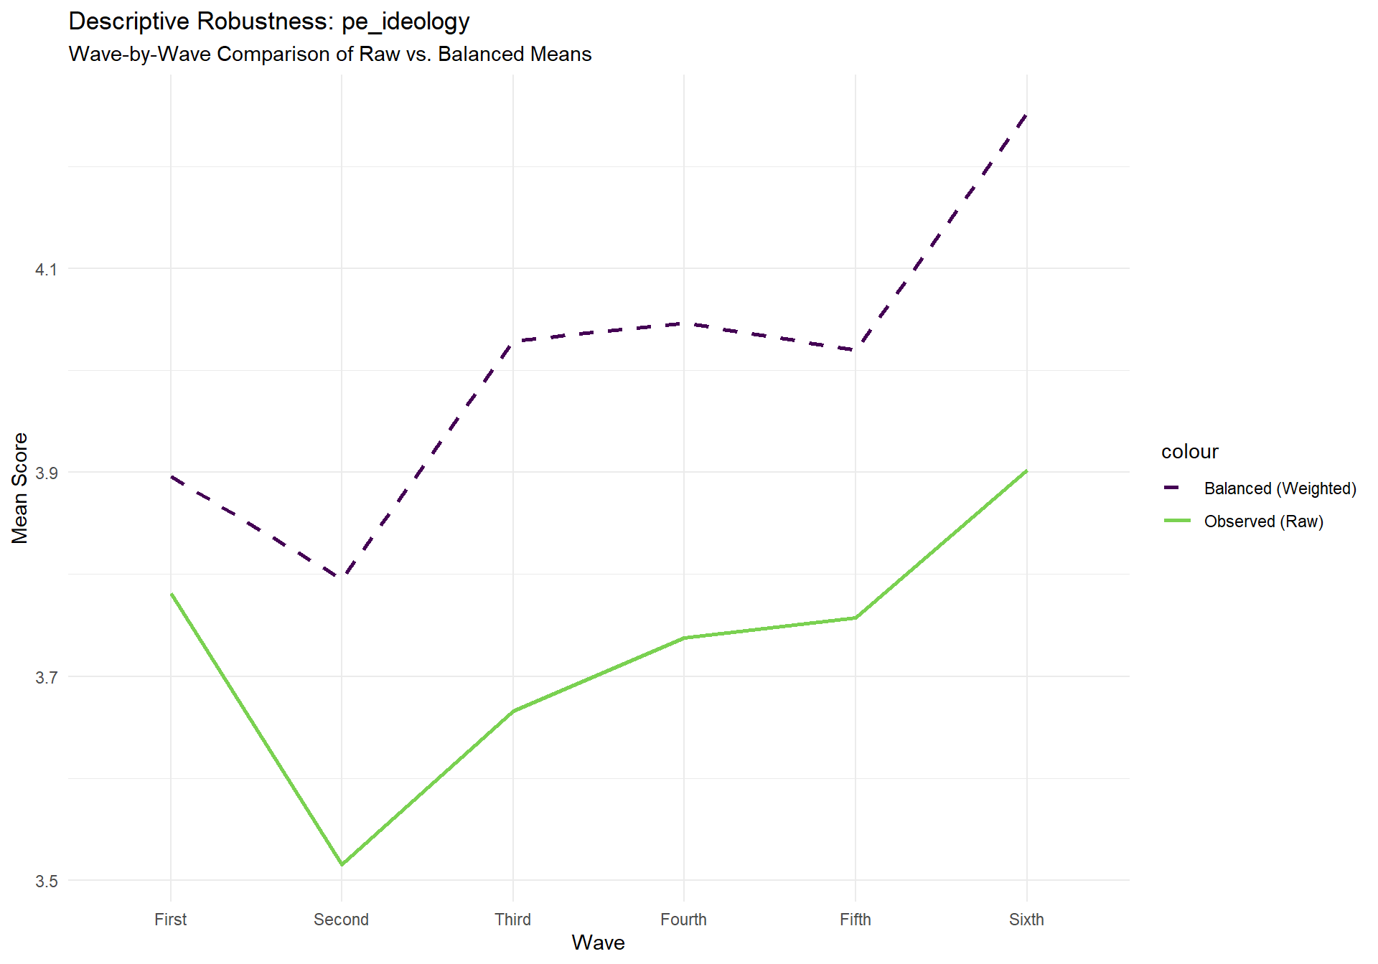
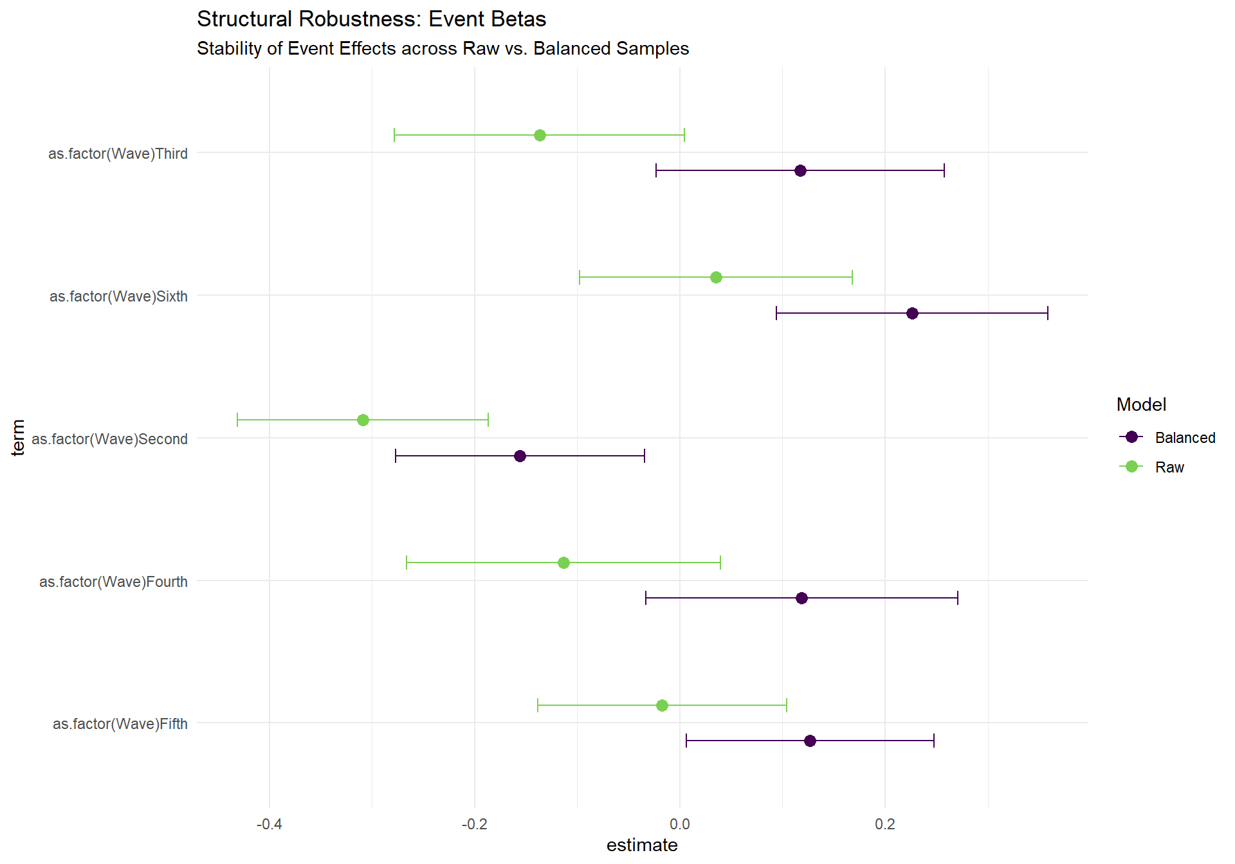
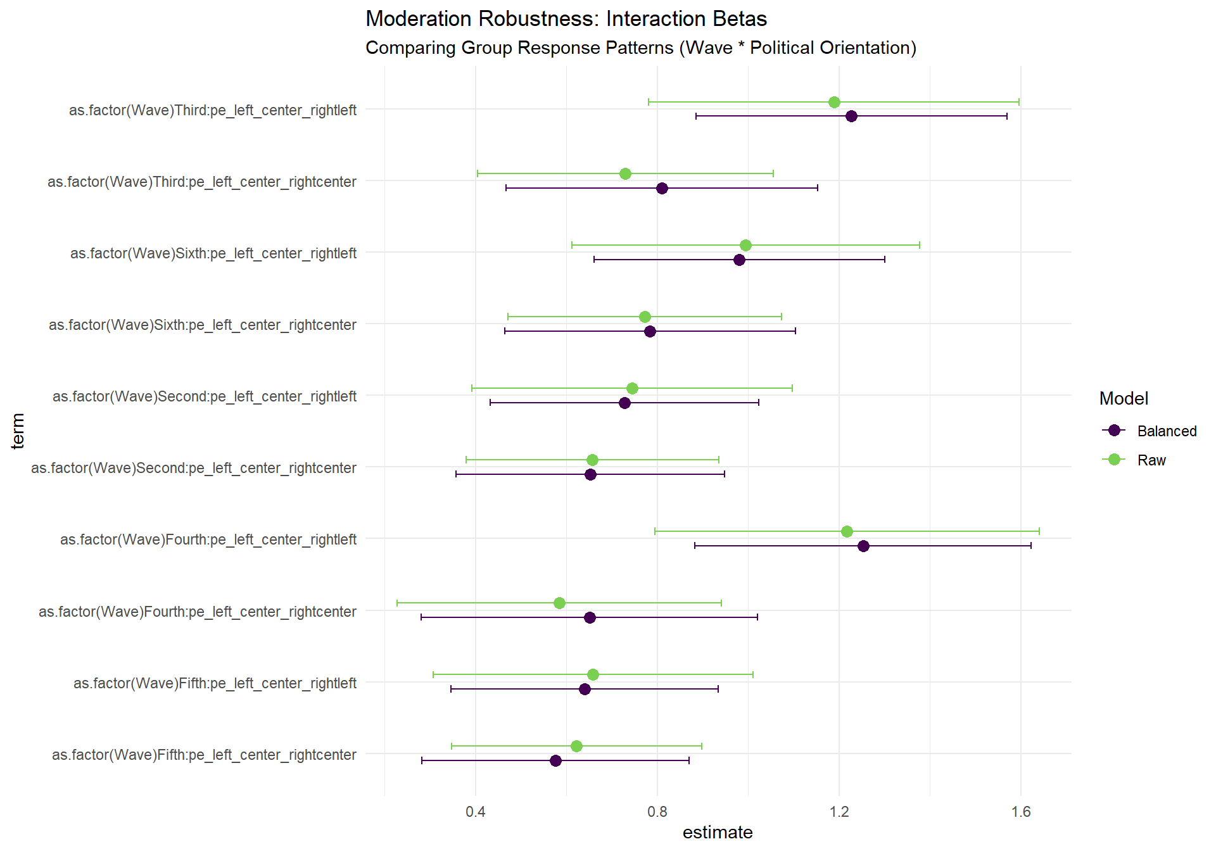

Behavioral Dimension, Equal Balancing Model
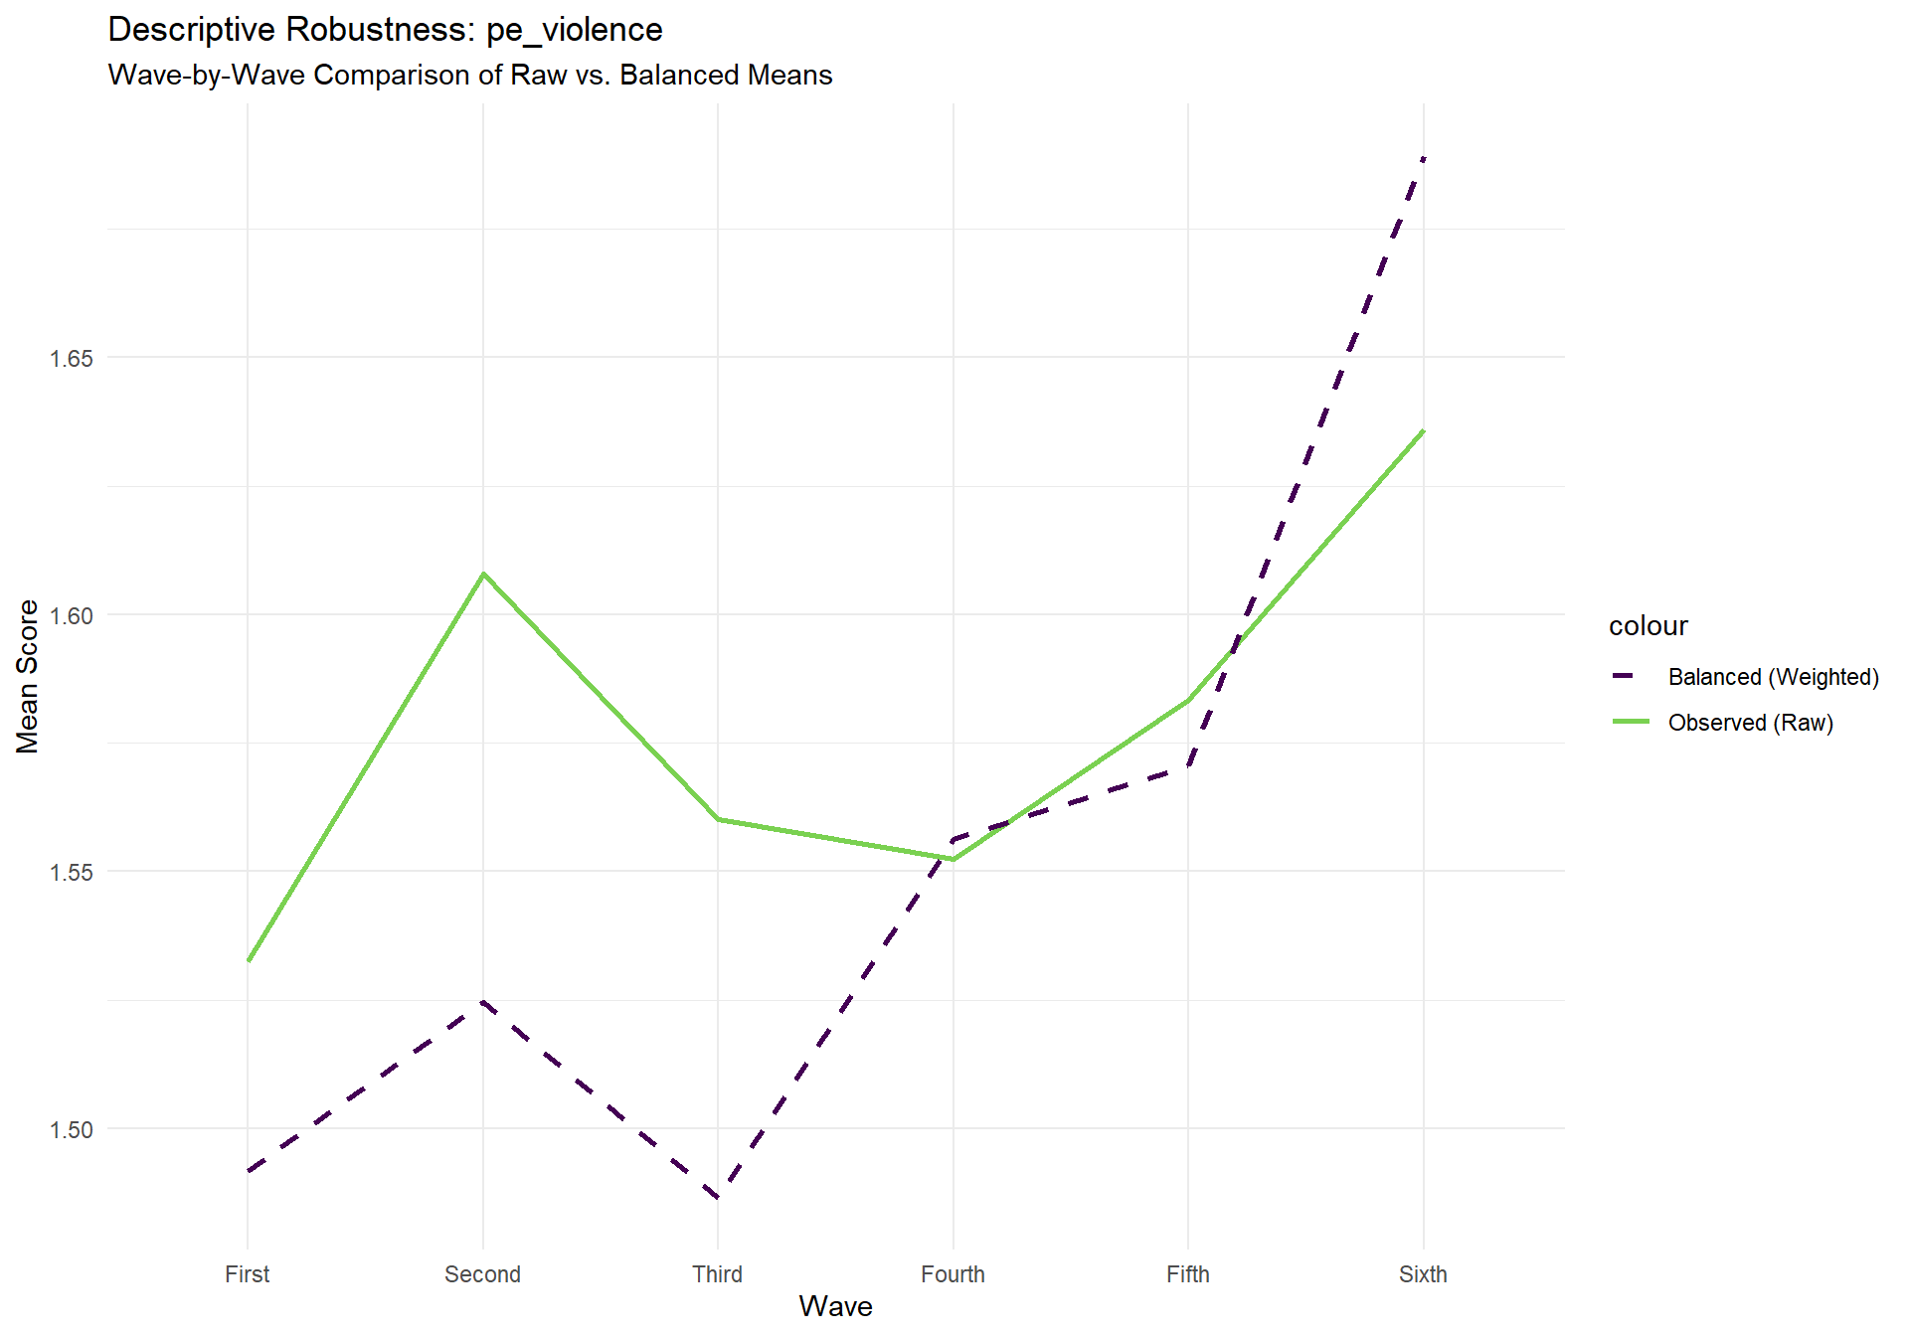
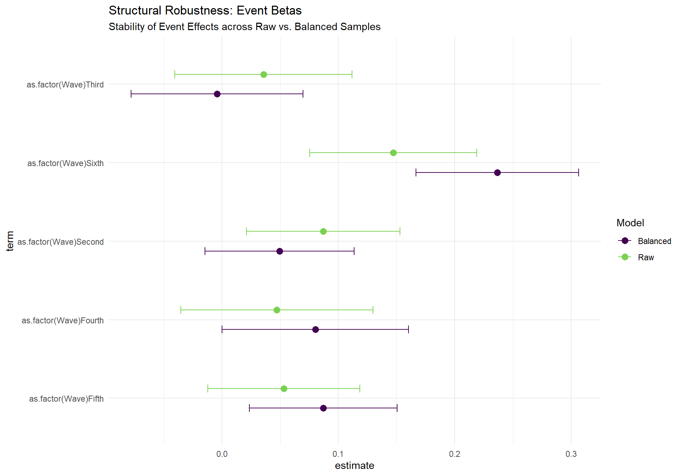
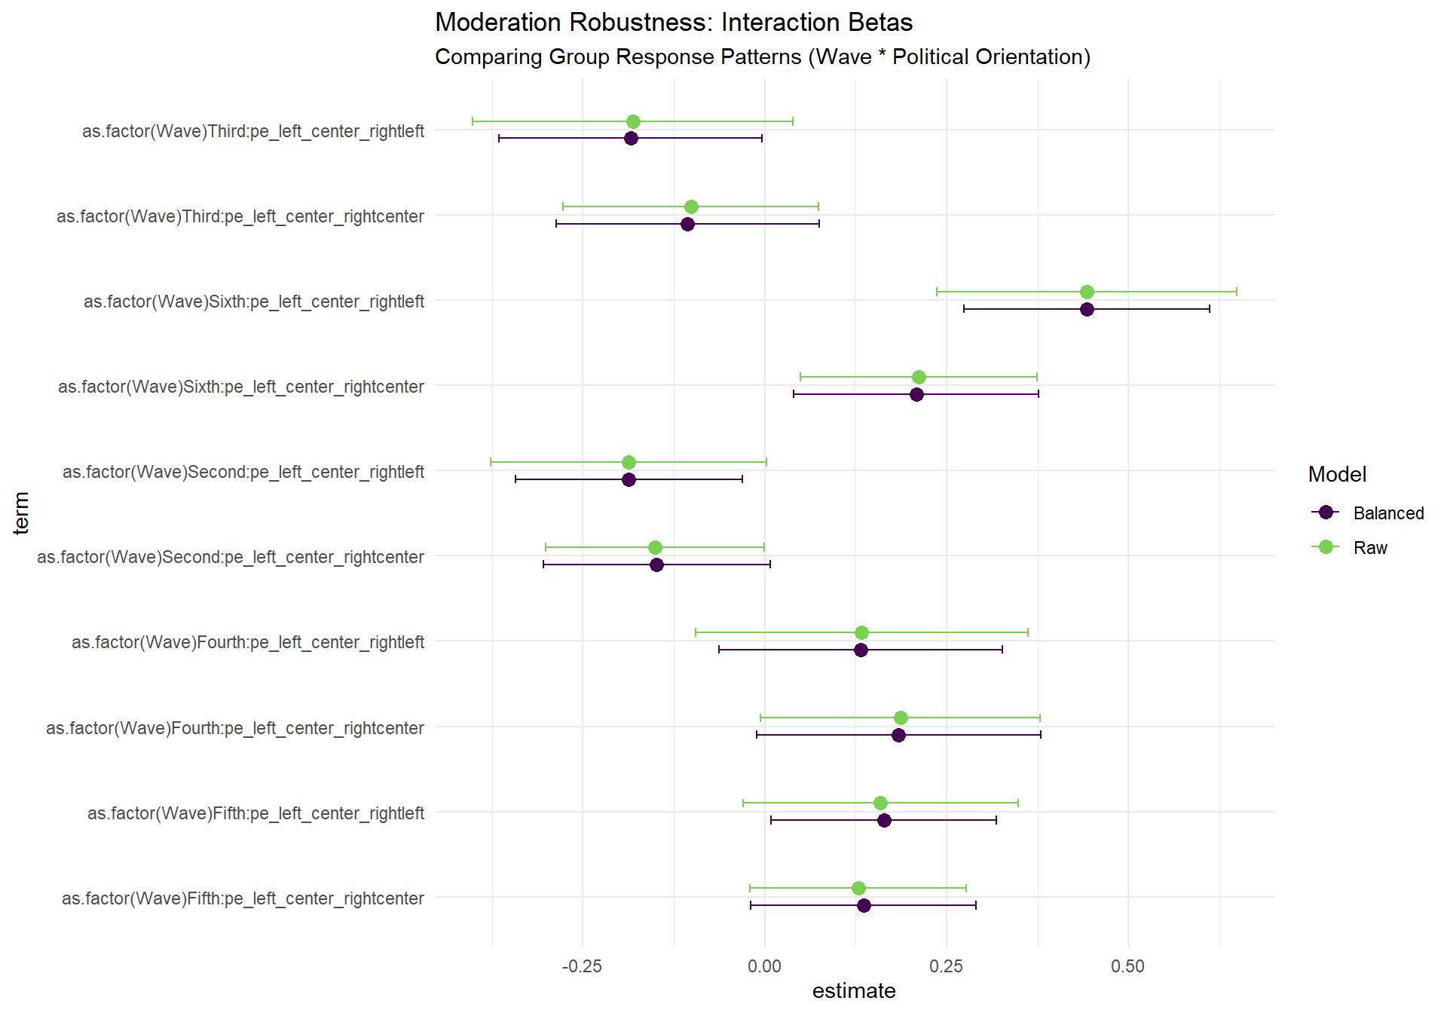

Social Dimension, Equal Balancing Model
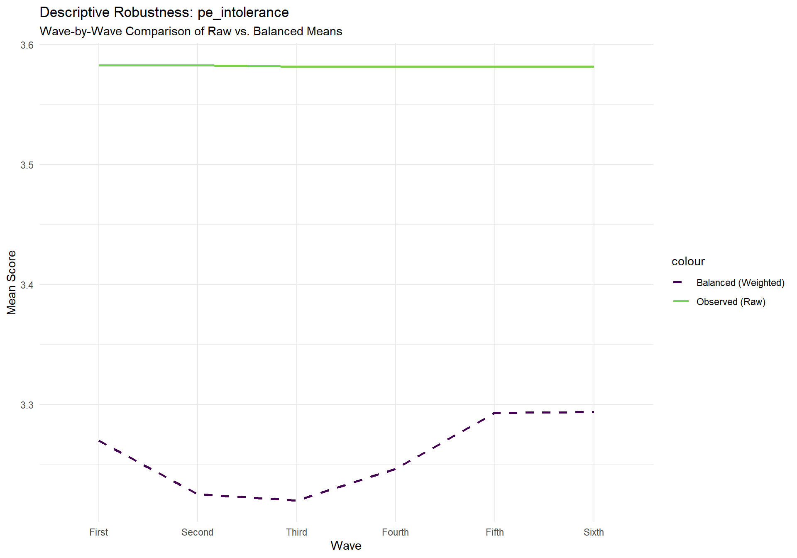
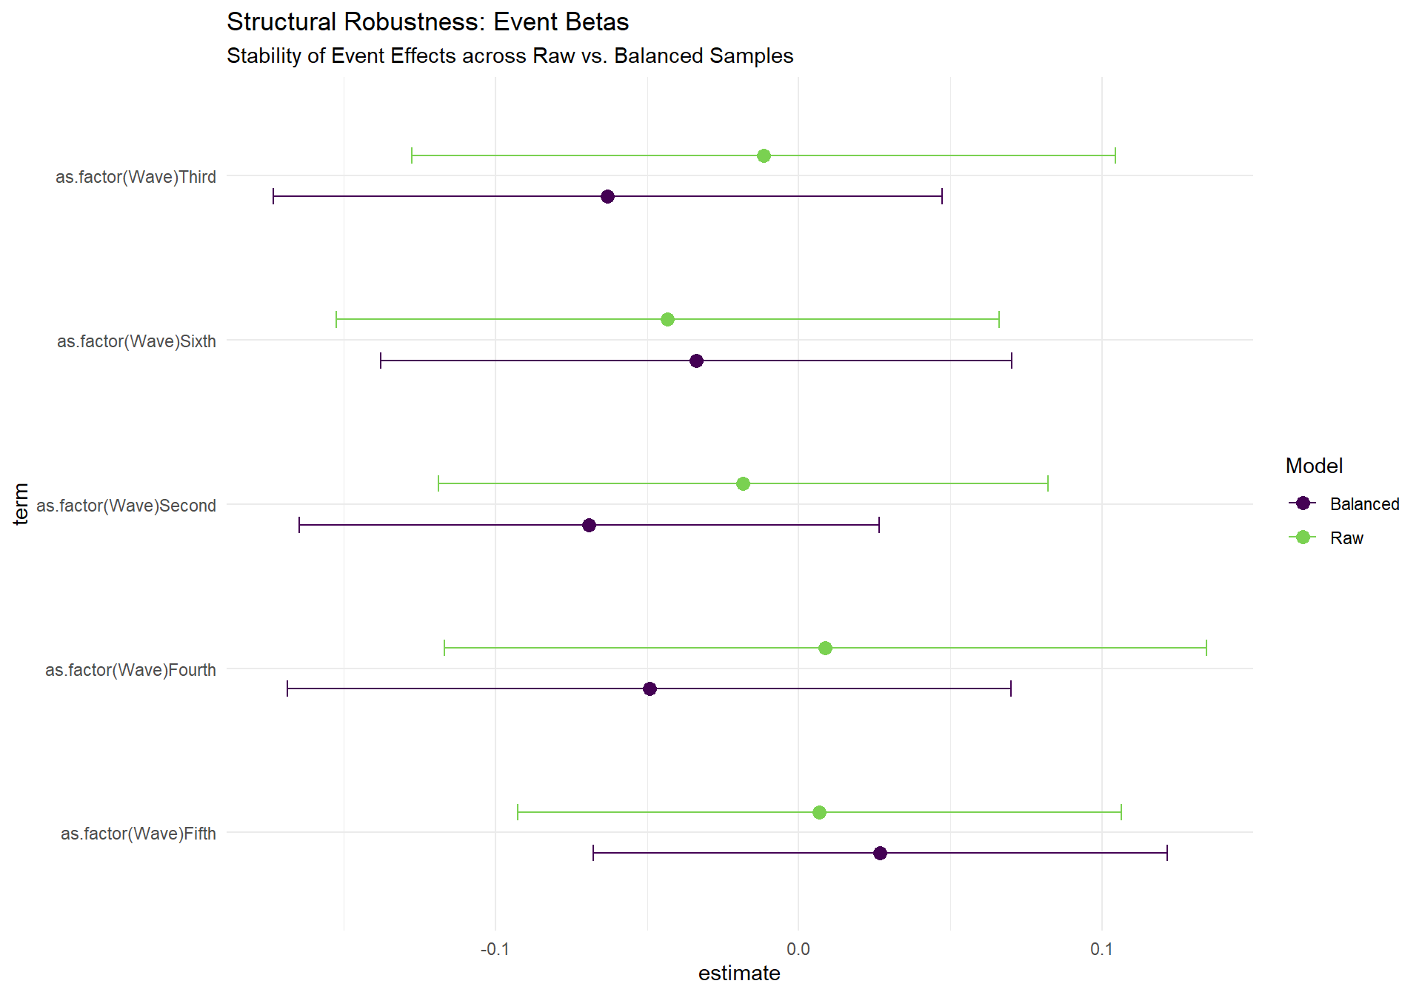
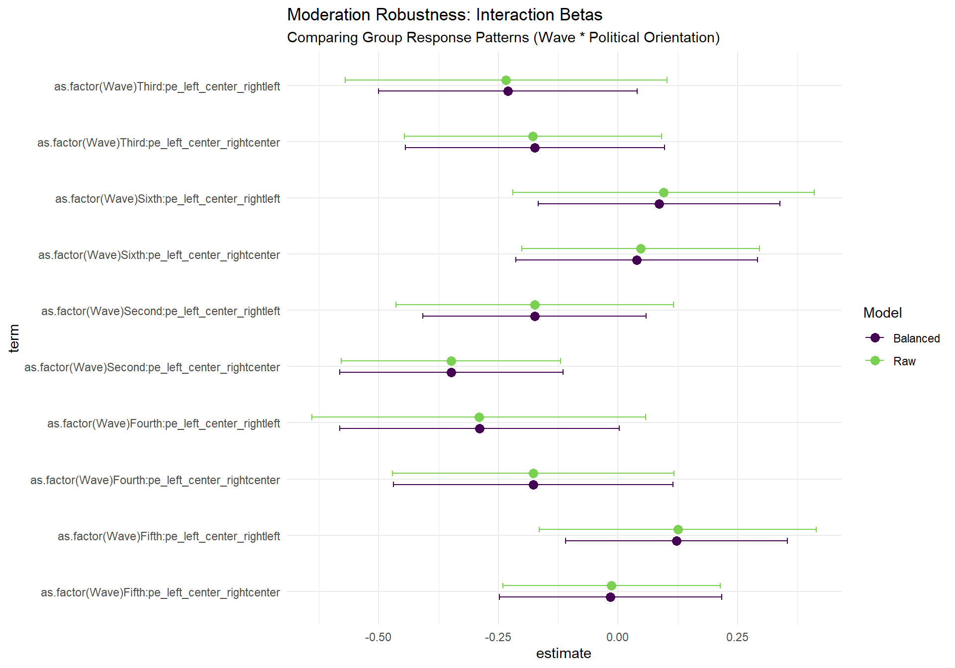

Cognitive Dimension, Targetted Balancing Model
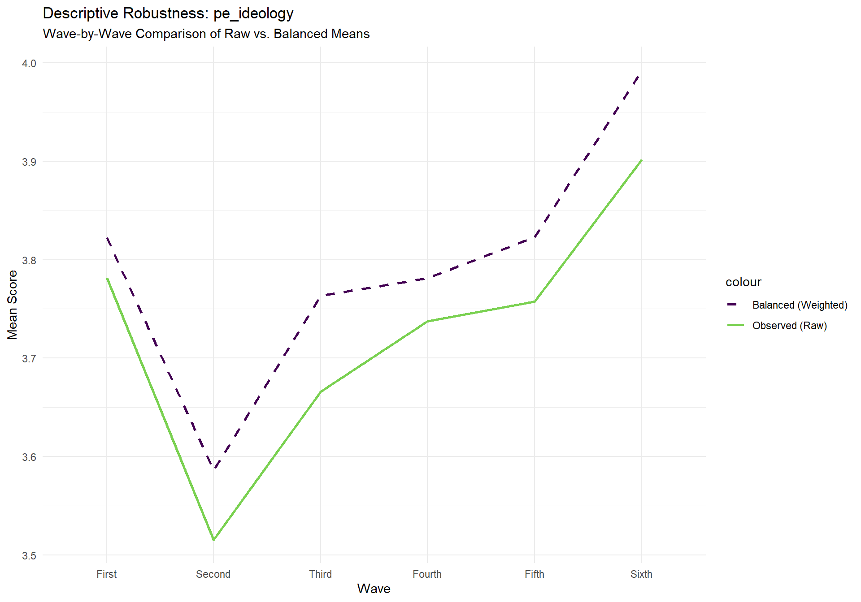
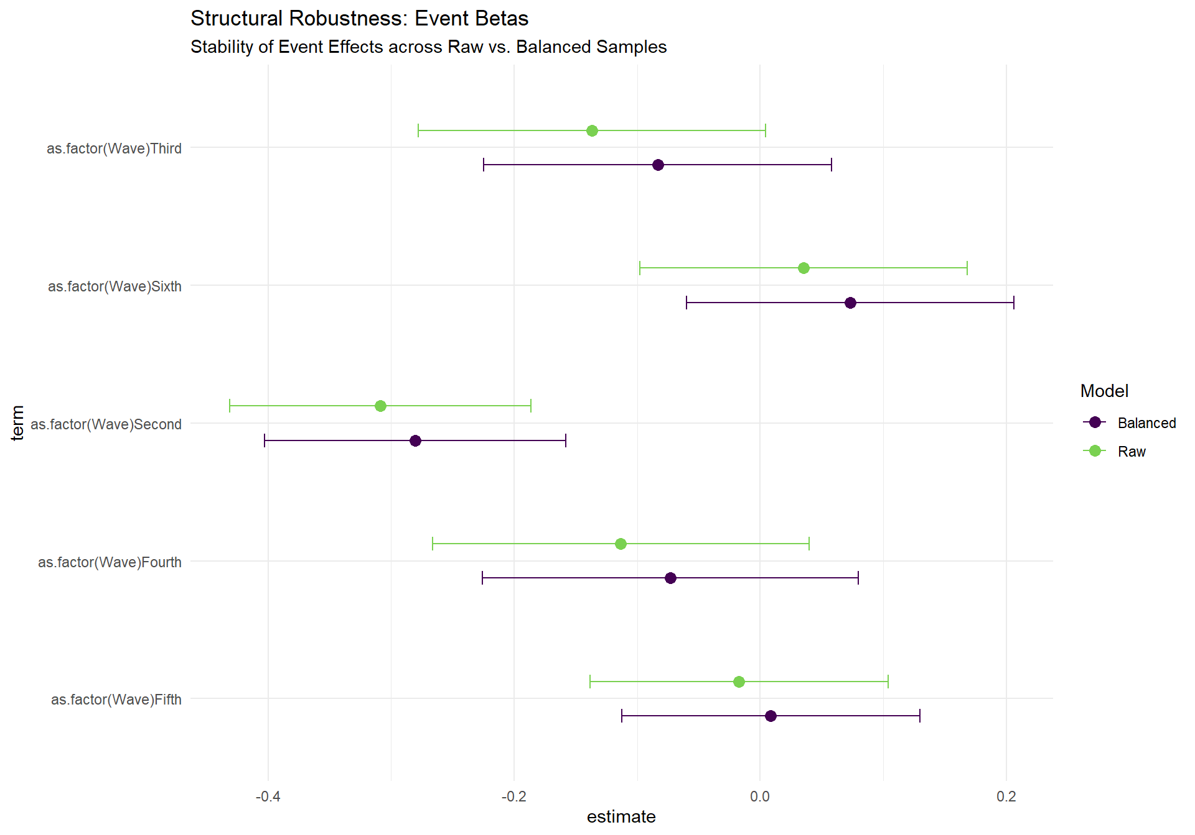
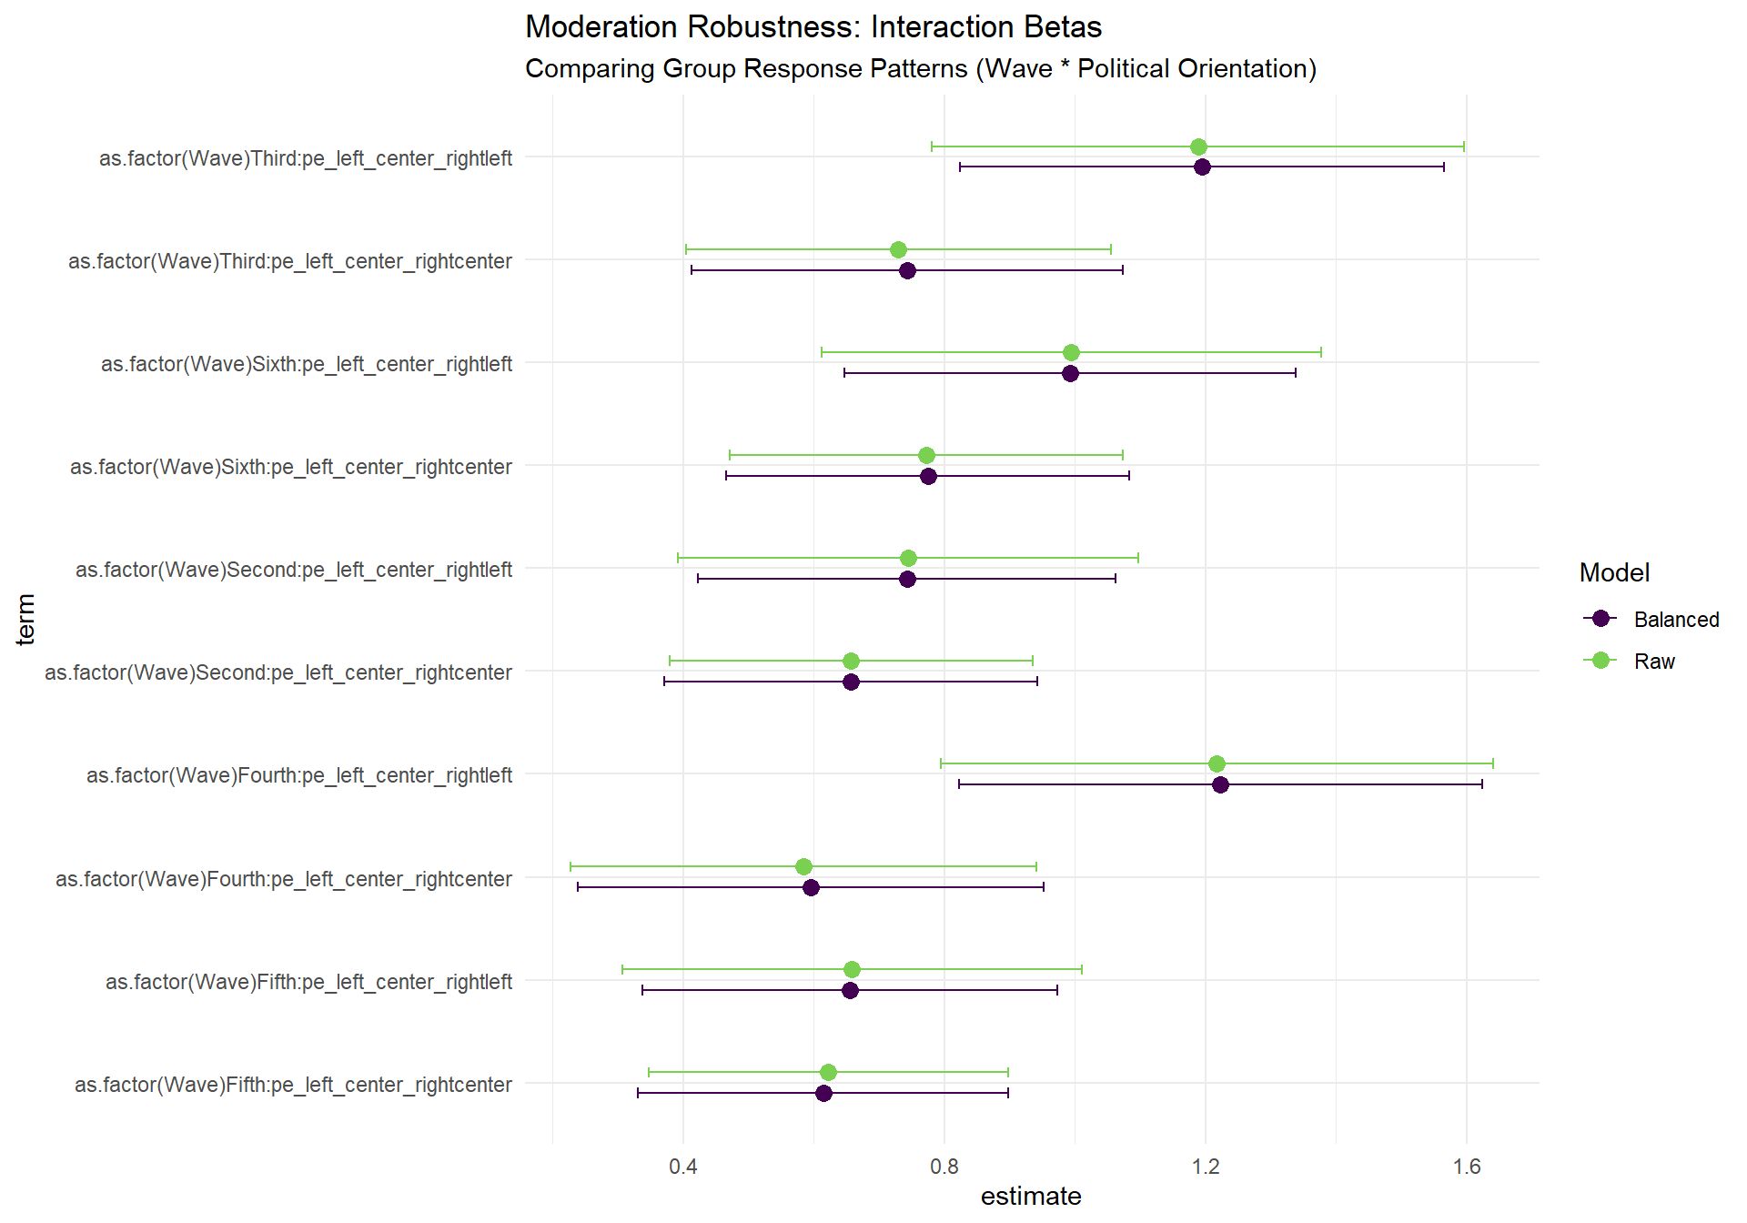

Behavioral Dimension, Targeted Balancing Model
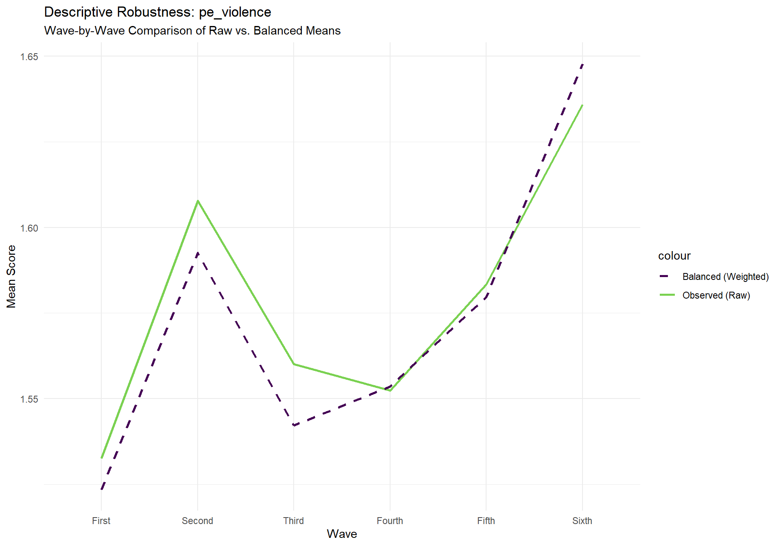
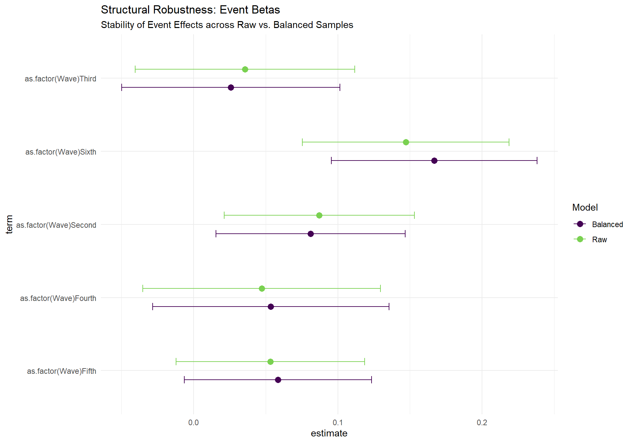
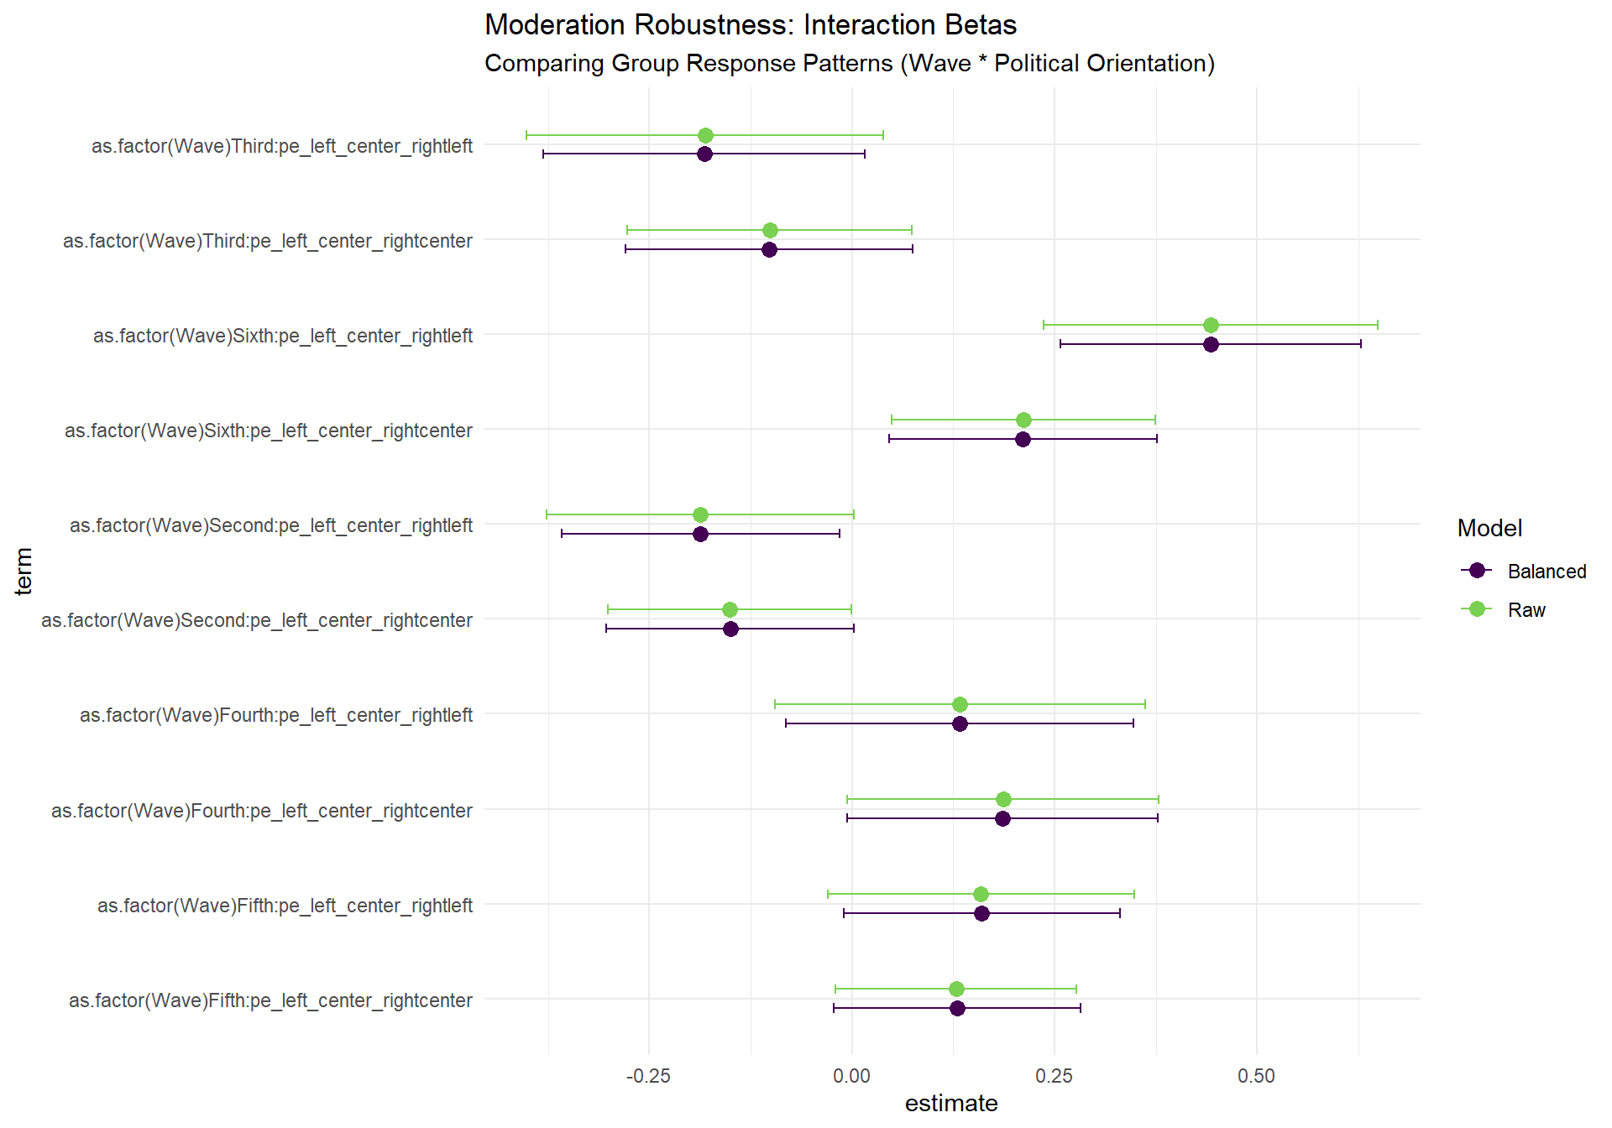

Social Dimension, Targeted Balancing Model
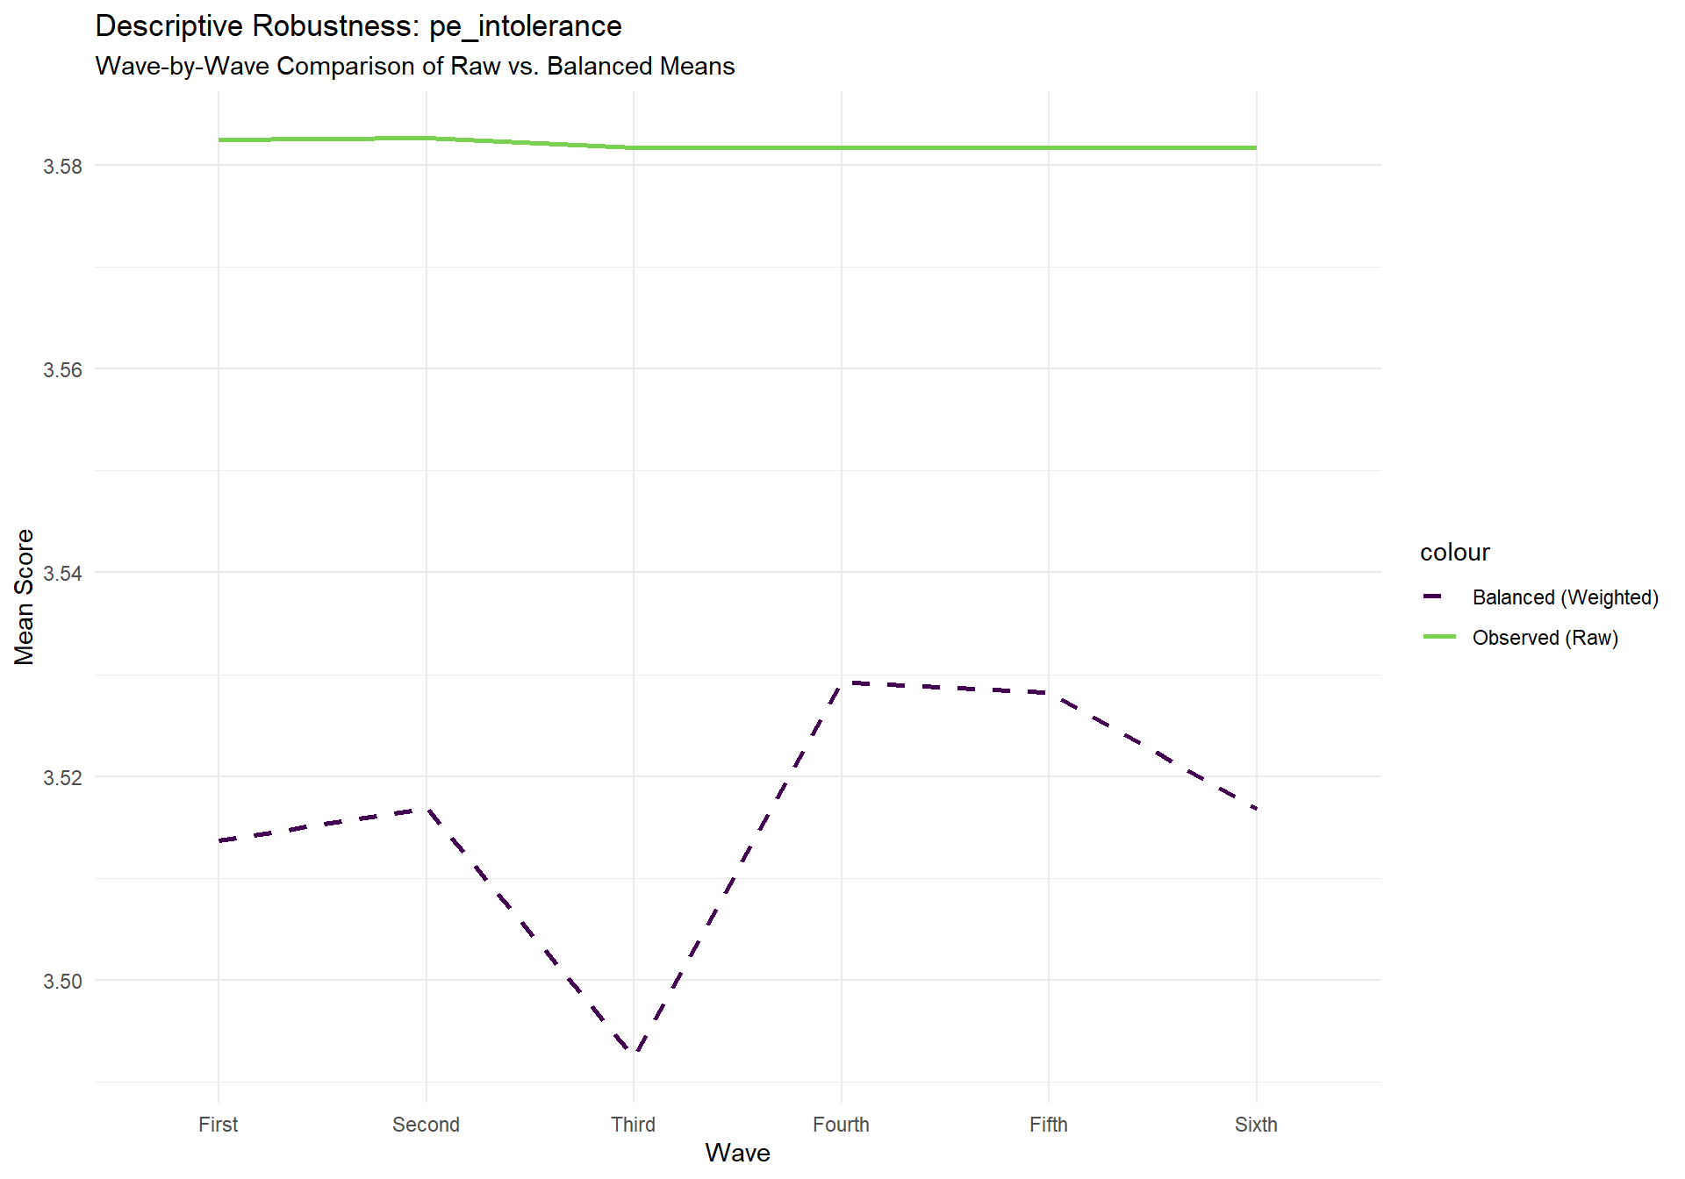
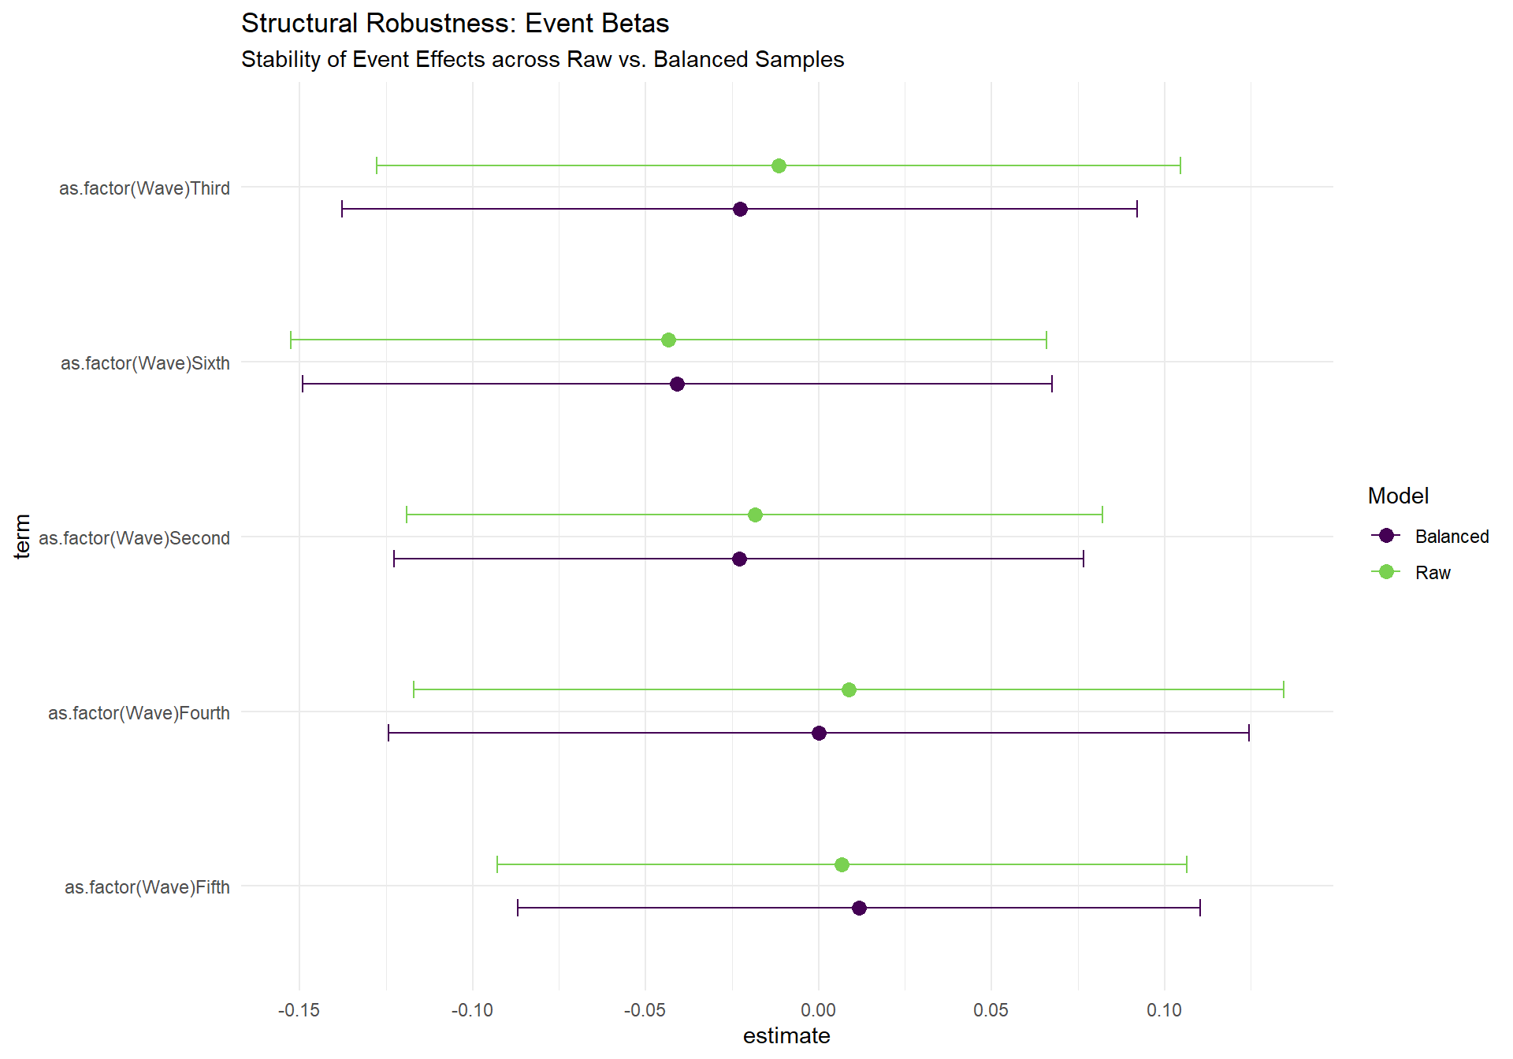
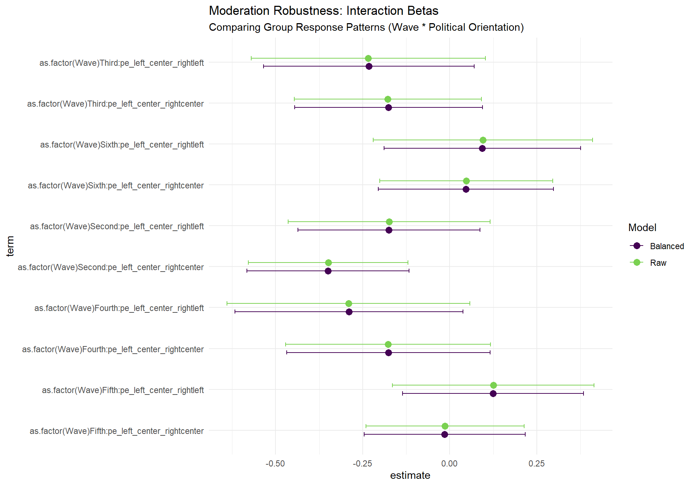
The core finding of this analysis is that the research results are structurally stable across all sampling conditions. Whether we look at the raw data, an equalized sample, or a census-targeted sample, the fundamental patterns remain unchanged. This triple-layer validation (Raw vs. Equal vs. Census) confirms that the study is measuring a real-world socio-political phenomenon in Israel.

Extremists' Transitions
The transition analysis utilizes longitudinal panel data from waves three and four to track individual shifts into and out of the extremist tail across cognitive, behavioral, and social dimensions. By calculating onset transitions (individuals becoming extremists) and cessation transitions (individuals leaving the extremist group), the analysis determines the delta transitions or the net change in the size of the extremist population. Furthermore, the analysis monitors changes in Extremism Intensity (EIN) across dimensions and within the multidimensional Extremism Rank 2 (ER2) group. This dual focus allows for distinguishing between fluctuations in the number of extremists and changes in the severity of radical beliefs or behaviors among those who remain in the tail.
The results indicate that extremism spreads through distinct mechanisms that vary by political orientation and dimension. In the cognitive dimension, the left-wing group experienced recruitment, with a delta transition of 3.6% (4 individuals) and a high stable intensity (6.61 to 6.62). Conversely, the right-wing group showed a slight demobilization (delta of -0.5%) but experienced an intensification of beliefs, with intensity rising from 6.47 to 6.74 (a 4.2% increase). The behavioral dimension revealed a significant recruitment mechanism for the center and left-wing groups, with delta transitions of 5.8% and 5.5%, respectively. In comparison, the right-wing group experienced notable demobilization (-6.4%). In the multidimensional ER2 analysis, the center-wing group demonstrated both a sharp recruitment (delta of 6.4%) and a significant intensification across all dimensions, most notably in behavioral intensity, which rose from 2.04 to 2.60 (a 27.6% increase). These findings suggest that while some groups grow in size through onset transitions, others radicalize through the intensification of existing views, confirming that socio-political events between waves three and four triggered heterogeneous responses across the political spectrum.

Transitions per Dimension
Table 8: Transition Analysis of the Cognitive (Ideology) Dimension
Group | Sample Population | Extremists (Third) | Extremists (Fourth) | Onset transitions | Cessation transitions | Delta Transitions | Intensity (Third) | Intensity (Fourth) | Intensity change
Overall Population | 100.0% (675) | 21.0% (142) | 21.8% (147) | 5.5%  (37) | 4.7%  (32) | 0.7%  (5) | 6.53 | 6.66 | 1.9% (0.13)
right | 58.2% (393) | 14.0% (55) | 13.5% (53) | 4.6%  (18) | 5.1%  (20) | -0.5%  (-2) | 6.47 | 6.74 | 4.2% (0.27)
center | 25.5% (172) | 12.2% (21) | 14.0% (24) | 5.8%  (10) | 4.1%  (7) | 1.7%  (3) | 6.47 | 6.57 | 1.6% (0.10)
left | 16.3% (110) | 60.0% (66) | 63.6% (70) | 8.2%  (9) | 4.5%  (5) | 3.6%  (4) | 6.61 | 6.62 | 0.3% (0.02)
Notes: Sample Population shows the number of respondents present in both waves. Onset transitions: non-extremist in W1 and extremist in W2. Cessation transitions: extremist in W1 and non-extremist in W2. Delta: Onset - Cessation. Intensity metrics are calculated only for the extremist group in each wave. Intensity change: percentage change and raw difference between waves.
Table 9: Transition Analysis of the Behavioral (Violence) Dimension
Group | Sample Population | Extremists (Third) | Extremists (Fourth) | Onset transitions | Cessation transitions | Delta Transitions | Intensity (Third) | Intensity (Fourth) | Intensity change
Overall Population | 100.0% (675) | 31.0% (209) | 29.6% (200) | 10.4% (70) | 11.7% (79) | -1.3%  (-9) | 2.51 | 2.64 | 5.2% (0.13)
right | 58.2% (393) | 34.1% (134) | 27.7% (109) | 7.9%  (31) | 14.2% (56) | -6.4%  (-25) | 2.61 | 2.69 | 2.8% (0.07)
center | 25.5% (172) | 27.3% (47) | 33.1% (57) | 14.0% (24) | 8.1%  (14) | 5.8%  (10) | 2.42 | 2.74 | 13.1% (0.32)
left | 16.3% (110) | 25.5% (28) | 30.9% (34) | 13.6% (15) | 8.2%  (9) | 5.5%  (6) | 2.18 | 2.34 | 7.4% (0.16)
Notes: Sample Population shows the number of respondents present in both waves. Onset transitions: non-extremist in W1 and extremist in W2. Cessation transitions: extremist in W1 and non-extremist in W2. Delta: Onset - Cessation. Intensity metrics are calculated only for the extremist group in each wave. Intensity change: percentage change and raw difference between waves.
Table 10: Transition Analysis of the Social (Intolerance) Dimension
Group | Sample Population | Extremists (Third) | Extremists (Fourth) | Onset transitions | Cessation transitions | Delta Transitions | Intensity (Third) | Intensity (Fourth) | Intensity change
Overall Population | 100.0% (675) | 16.9% (114) | 16.9% (114) | 7.3%  (49) | 7.3%  (49) | 0.0% (0) | 6.26 | 6.20 | -1.0%  (-0.06)
right | 58.2% (393) | 24.9% (98) | 25.2% (99) | 10.4% (41) | 10.2% (40) | 0.3% (1) | 6.29 | 6.20 | -1.3%  (-0.08)
center | 25.5% (172) | 8.7%  (15) | 8.7%  (15) | 4.7%  (8) | 4.7%  (8) | 0.0% (0) | 6.17 | 6.19 | 0.3% (0.02)
left | 16.3% (110) | 0.9%  (1) | 0.0%  (0) | 0.0%  (0) | 0.9%  (1) | -0.9% (-1) | 5.50 | NaN | NaN% (NaN)
Notes: Sample Population shows the number of respondents present in both waves. Onset transitions: non-extremist in W1 and extremist in W2. Cessation transitions: extremist in W1 and non-extremist in W2. Delta: Onset - Cessation. Intensity metrics are calculated only for the extremist group in each wave. Intensity change: percentage change and raw difference between waves.

Extremism Rank 2 (ER2)
Table 11: Transition Analysis of ER2 Cognitive (Ideology) Dimension
Group | Sample Population | Extremists (Third) | Extremists (Fourth) | Onset transitions | Cessation transitions | Delta Transitions | Intensity (Third) | Intensity (Fourth) | Intensity change
Overall Population | 100.0% (675) | 11.7% (79) | 13.5% (91) | 7.7%  (52) | 5.9%  (40) | 1.8%  (12) | 5.14 | 5.32 | 3.6% (0.18)
right | 58.2% (393) | 15.3% (60) | 14.5% (57) | 7.6%  (30) | 8.4%  (33) | -0.8%  (-3) | 4.95 | 5.30 | 7.0% (0.35)
center | 25.5% (172) | 2.9%  (5) | 9.3%  (16) | 7.6%  (13) | 1.2%  (2) | 6.4%  (11) | 3.18 | 3.96 | 24.8% (0.79)
left | 16.3% (110) | 12.7% (14) | 16.4% (18) | 8.2%  (9) | 4.5%  (5) | 3.6%  (4) | 6.63 | 6.59 | -0.6%  (-0.04)
Notes: Sample Population shows the number of respondents present in both waves. Onset transitions: non-extremist in W1 and extremist in W2. Cessation transitions: extremist in W1 and non-extremist in W2. Delta: Onset - Cessation. Intensity metrics are calculated only for the extremist group in each wave. Intensity change: percentage change and raw difference between waves.
Table 12: Transition Analysis of ER2 Behavioral (Violence) Dimension
Group | Sample Population | Extremists (Third) | Extremists (Fourth) | Onset transitions | Cessation transitions | Delta Transitions | Intensity (Third) | Intensity (Fourth) | Intensity change
Overall Population | 100.0% (675) | 11.7% (79) | 13.5% (91) | 7.7%  (52) | 5.9%  (40) | 1.8%  (12) | 2.20 | 2.17 | -1.3%  (-0.03)
right | 58.2% (393) | 15.3% (60) | 14.5% (57) | 7.6%  (30) | 8.4%  (33) | -0.8%  (-3) | 2.33 | 2.10 | -9.9%  (-0.23)
center | 25.5% (172) | 2.9%  (5) | 9.3%  (16) | 7.6%  (13) | 1.2%  (2) | 6.4%  (11) | 2.04 | 2.60 | 27.6% (0.56)
left | 16.3% (110) | 12.7% (14) | 16.4% (18) | 8.2%  (9) | 4.5%  (5) | 3.6%  (4) | 1.70 | 2.02 | 18.5% (0.31)
Notes: Sample Population shows the number of respondents present in both waves. Onset transitions: non-extremist in W1 and extremist in W2. Cessation transitions: extremist in W1 and non-extremist in W2. Delta: Onset - Cessation. Intensity metrics are calculated only for the extremist group in each wave. Intensity change: percentage change and raw difference between waves.
Table 13: Transition Analysis of ER2 Social (Intolerance) Dimension
Group | Sample Population | Extremists (Third) | Extremists (Fourth) | Onset transitions | Cessation transitions | Delta Transitions | Intensity (Third) | Intensity (Fourth) | Intensity change
Overall Population | 100.0% (675) | 11.7% (79) | 13.5% (91) | 7.7%  (52) | 5%  (40) | 1.8% (12) | 5.35 | 5.13 | -4.1%  (-0.22)
right | 58.2% (393) | 15.3% (60) | 14.5% (57) | 7.6%  (30) | 8.4%  (33) | -0.8% (-3) | 6.02 | 5.96 | -0.9%  (-0.05)
center | 25.5% (172) | 2.9%  (5) | 9.3%  (16) | 7.6%  (13) | 1.2%  (2) | 6.4% (11) | 5.77 | 5.06 | -12.3% (-0.71)
left | 16.3% (110) | 12.7% (14) | 16.4% (18) | 8.2%  (9) | 4.5%  (5) | 3.6% (4) | 2.32 | 2.54 | 9.2% (0.21)
Notes: Sample Population shows the number of respondents present in both waves. Onset transitions: non-extremist in W1 and extremist in W2. Cessation transitions: extremist in W1 and non-extremist in W2. Delta: Onset - Cessation. Intensity metrics are calculated only for the extremist group in each wave. Intensity change: percentage change and raw difference between waves.

Descriptive Analysis

Survey Measures & Dimensions

Cognitive (Ideology) Dimension
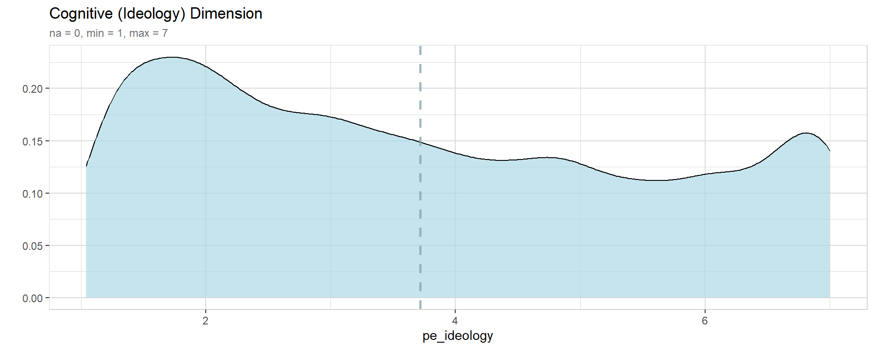
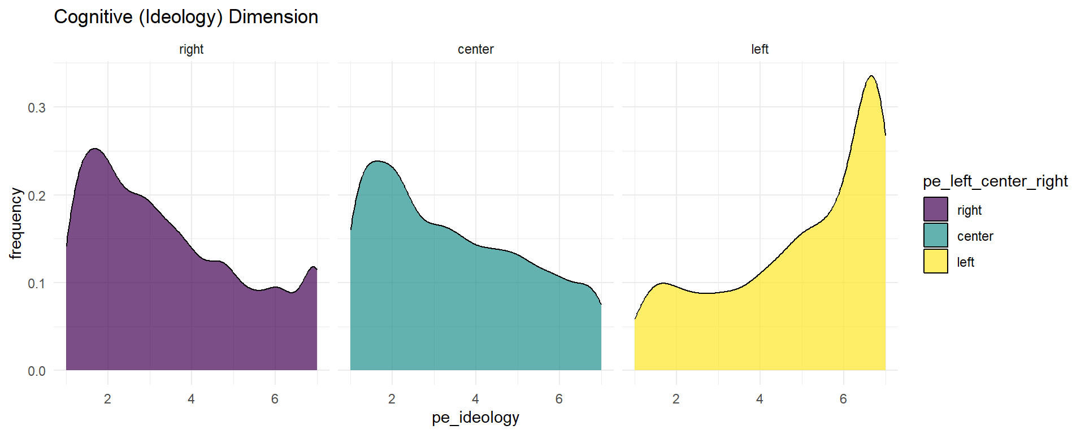
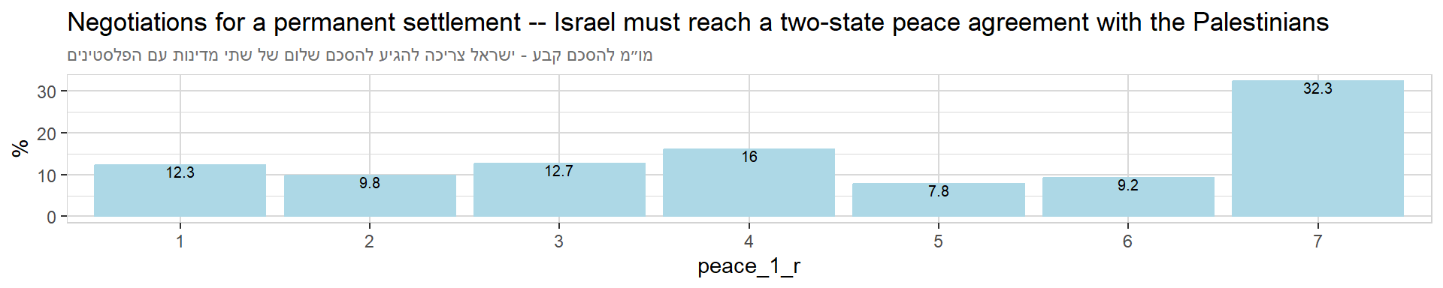
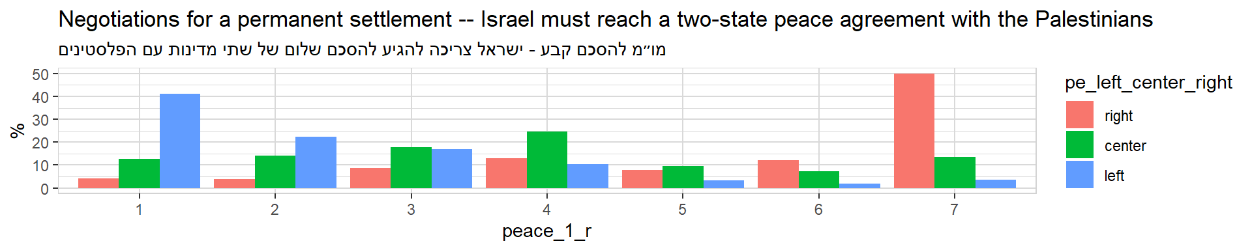
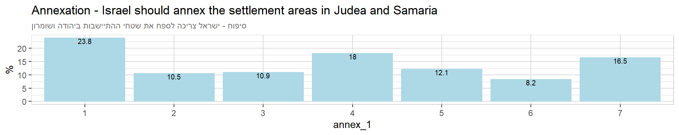
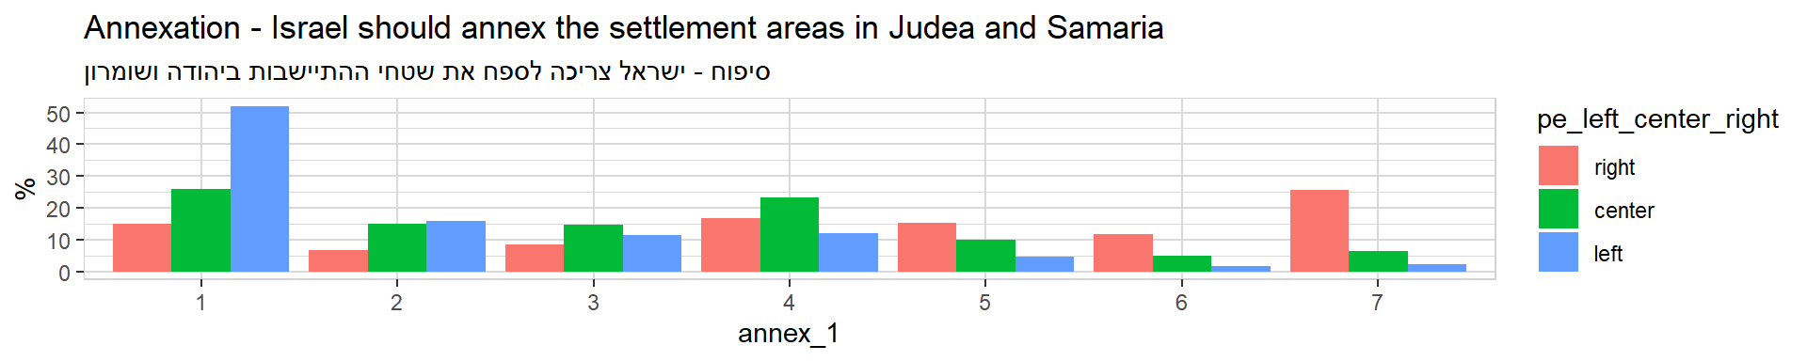
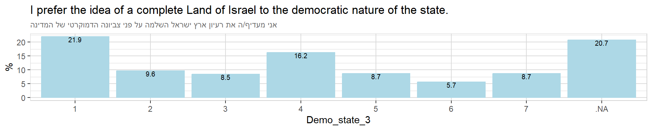
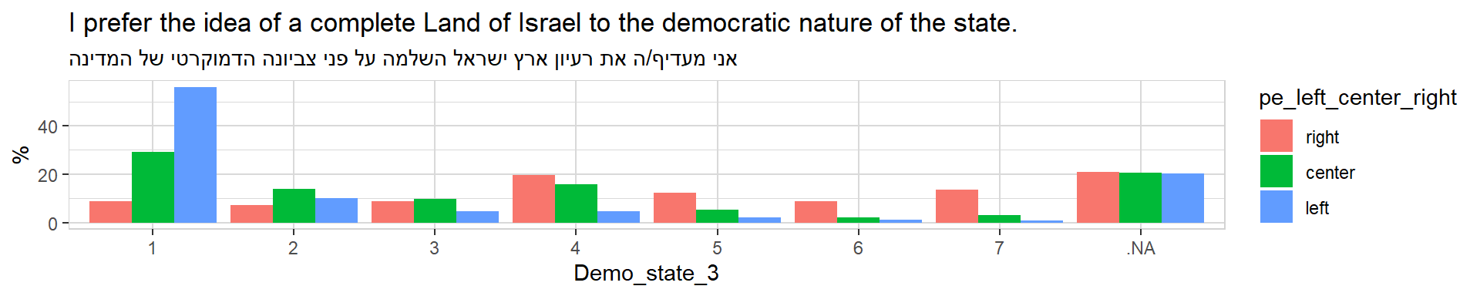

Behavioral (Violence) Dimension
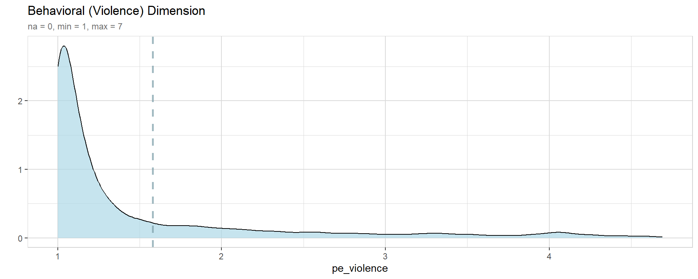
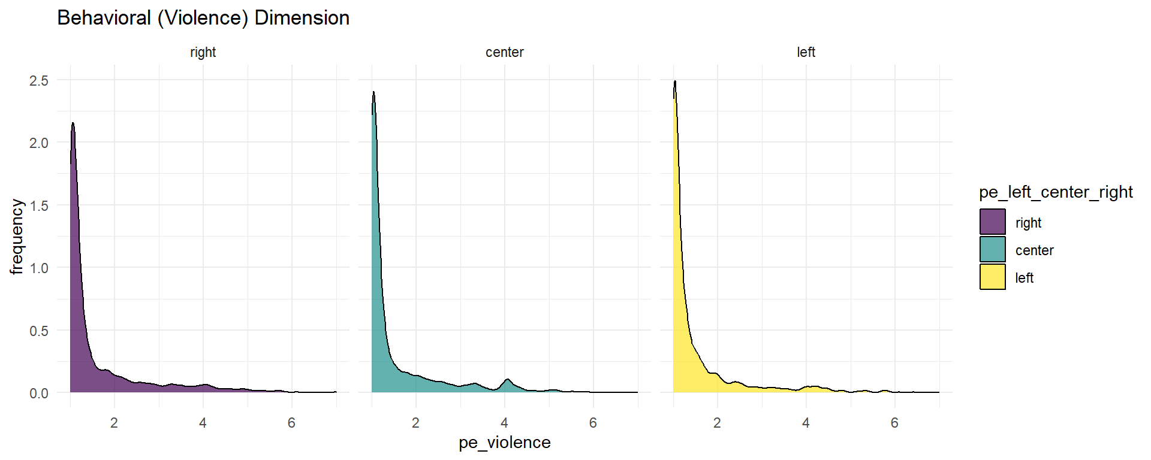

Violence against the Government
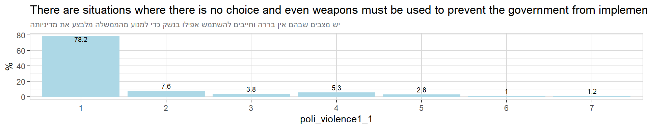
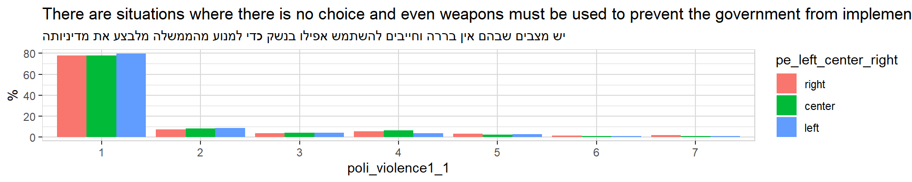
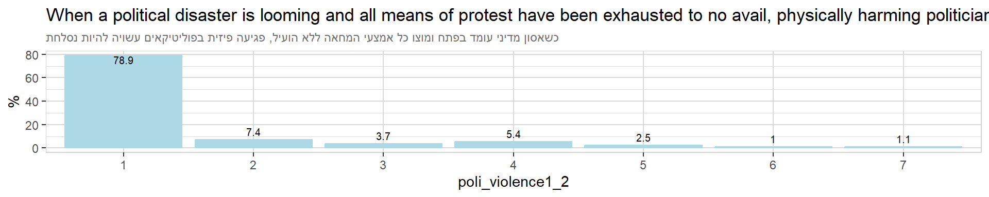
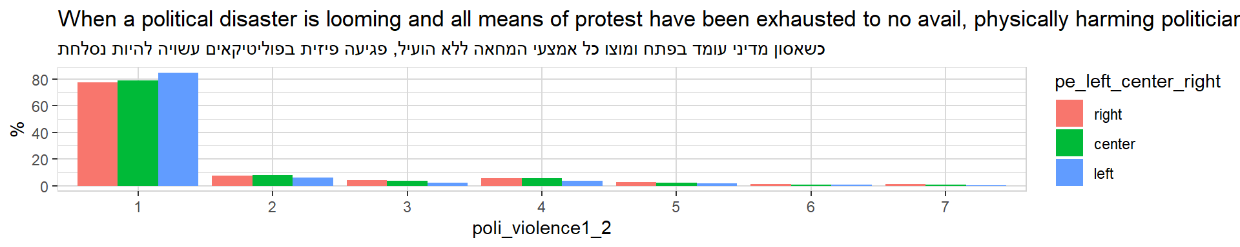
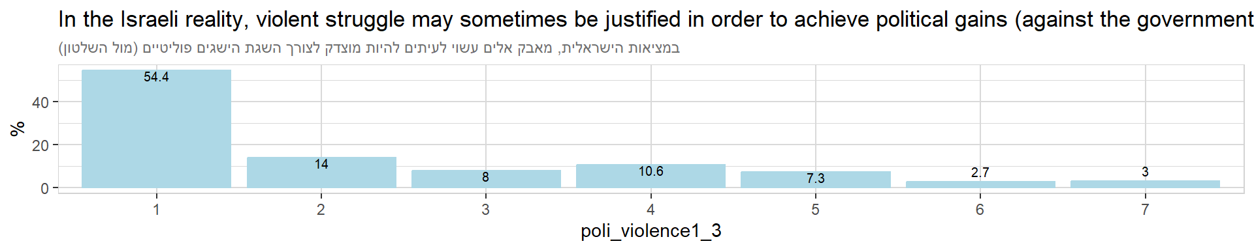
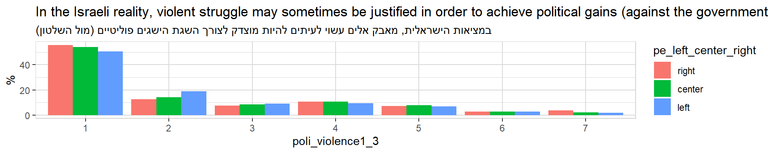
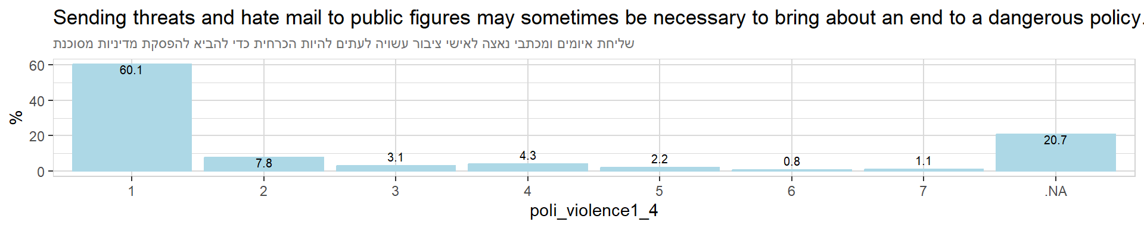
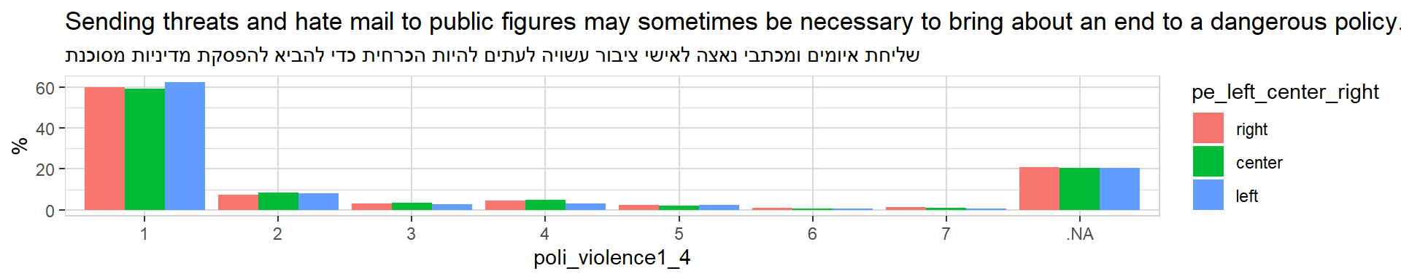

Violence against the Institutions
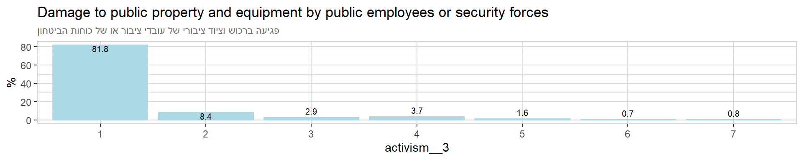
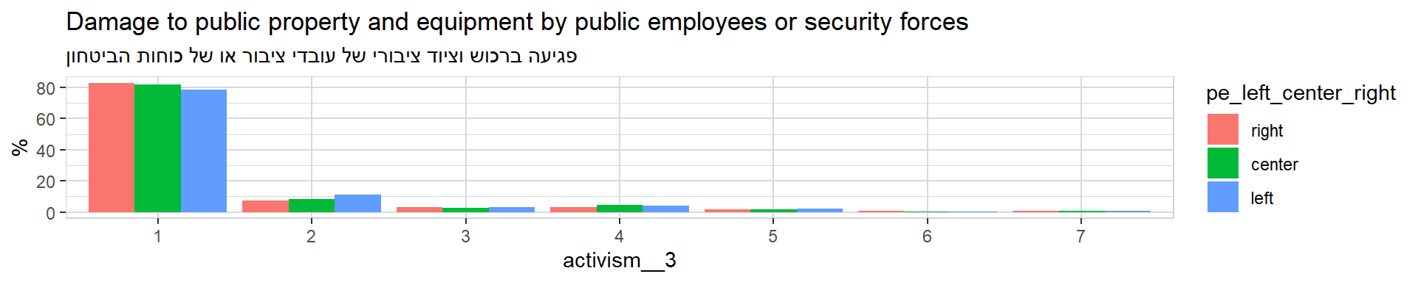
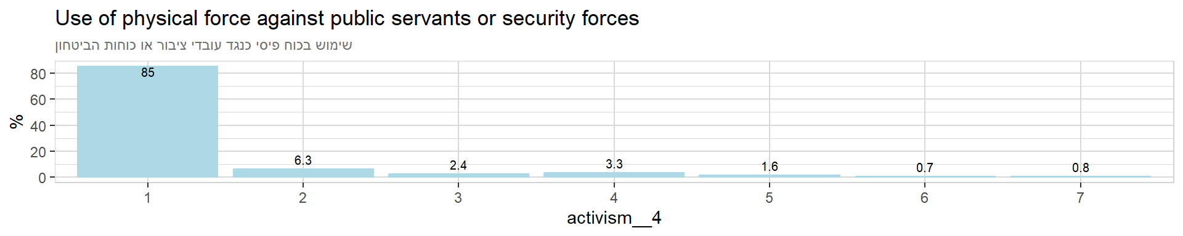
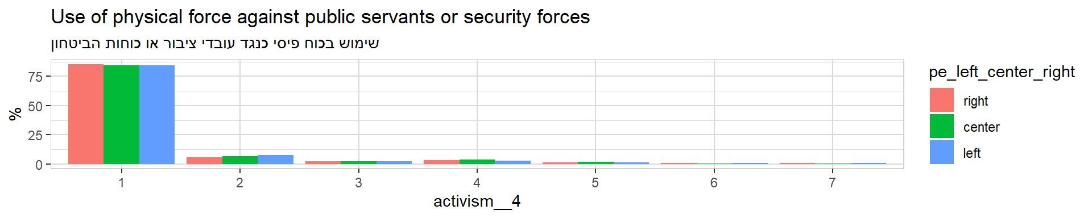

Violence against the Outgroup
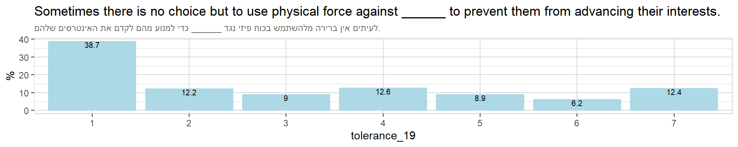
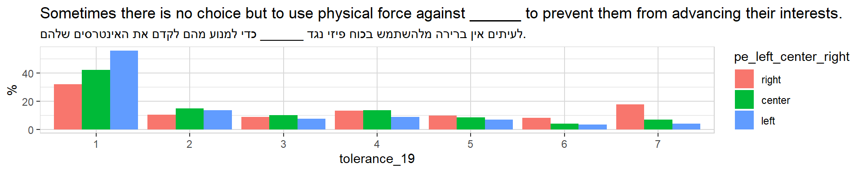
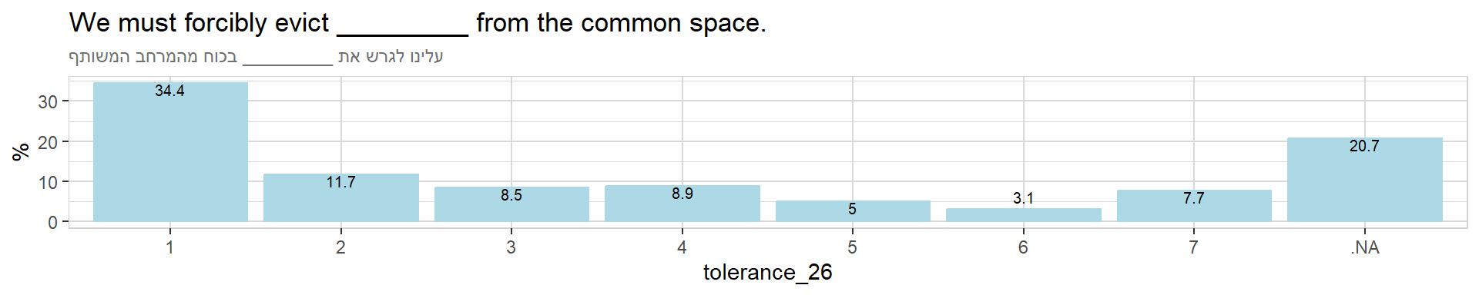
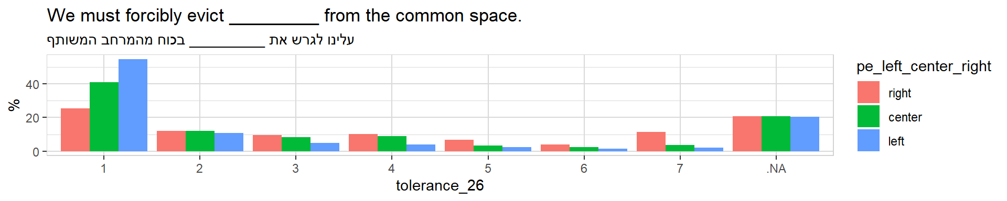

Social (Intolerance) Dimension
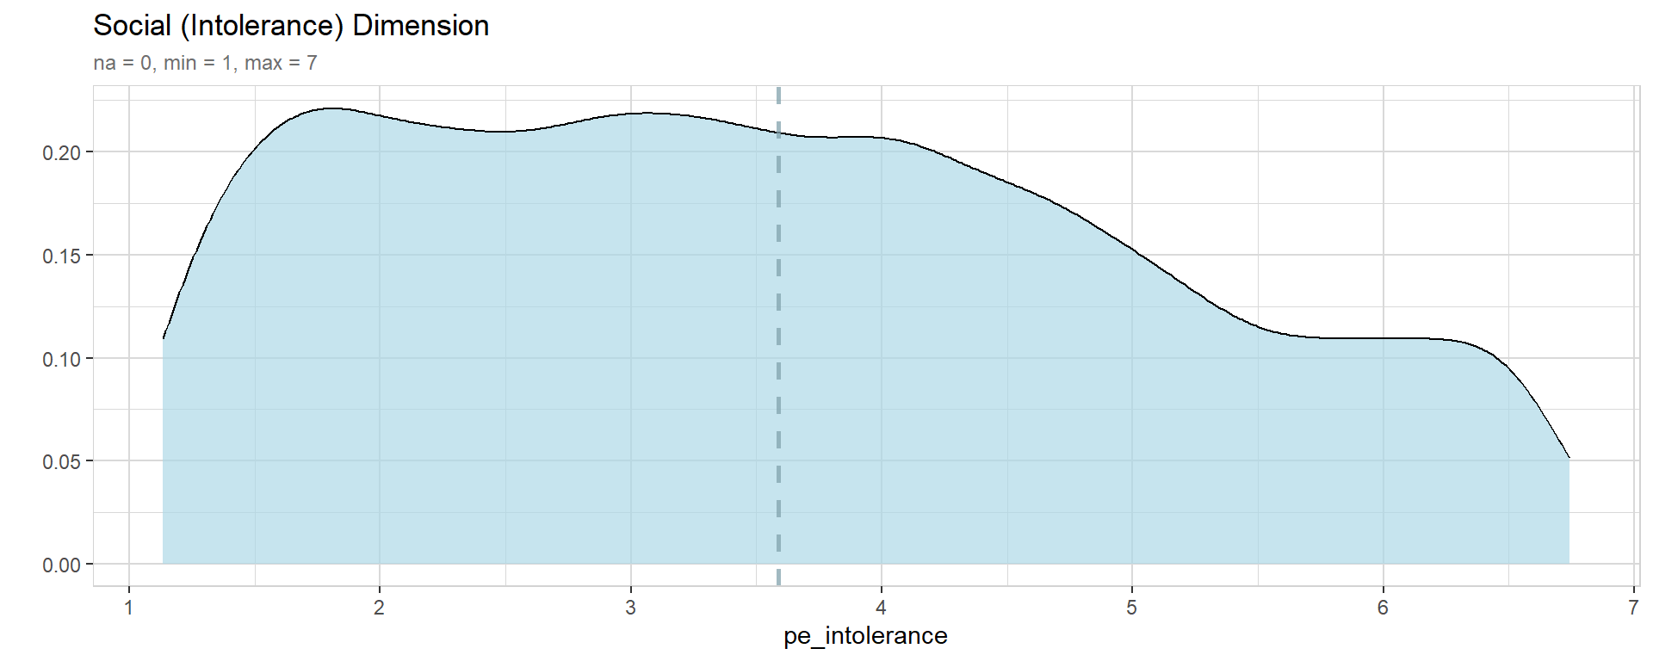
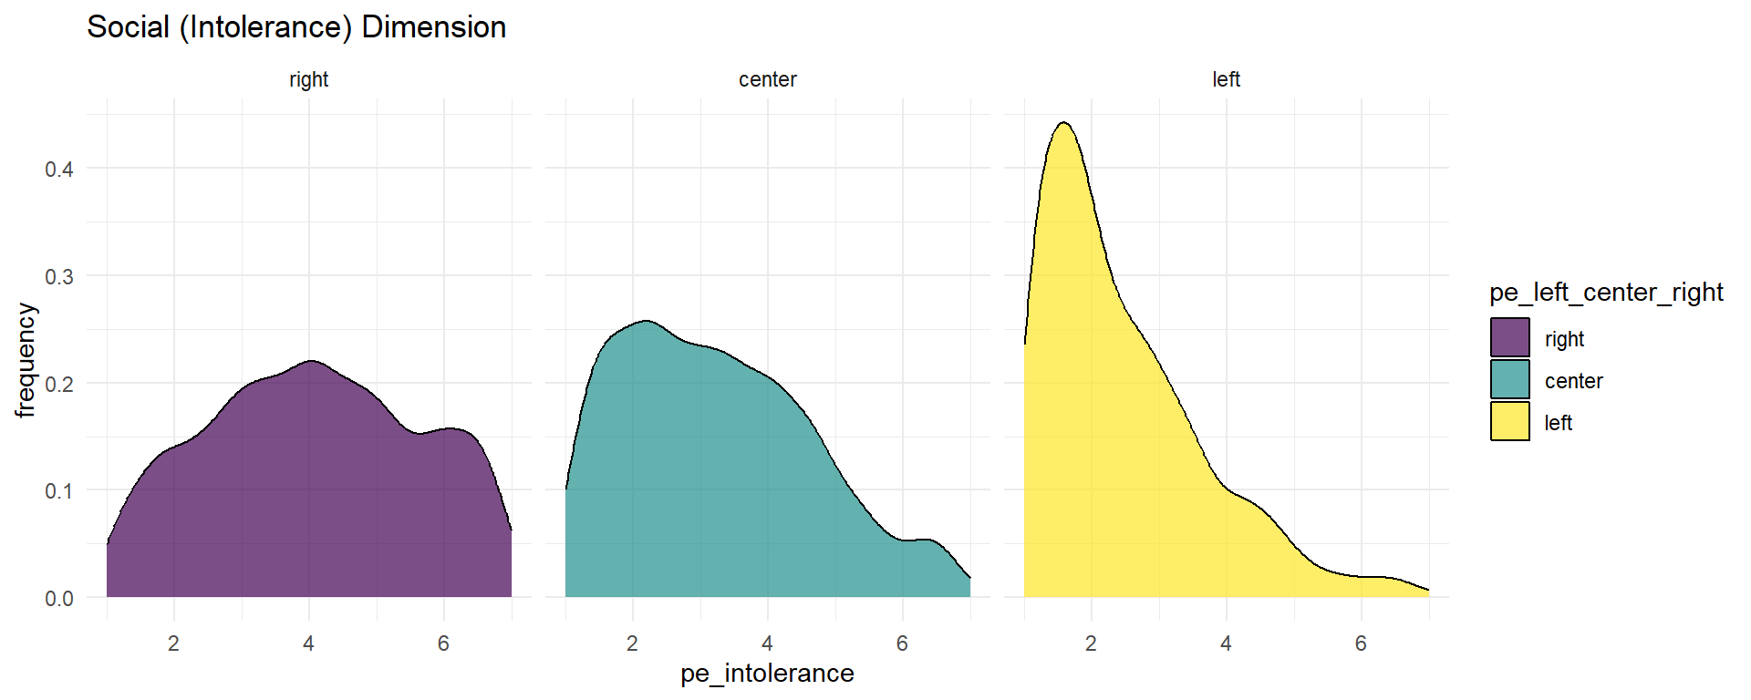

Social Distancing
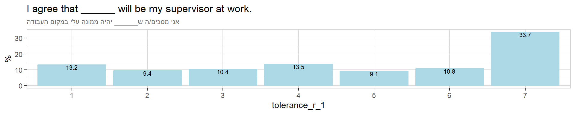
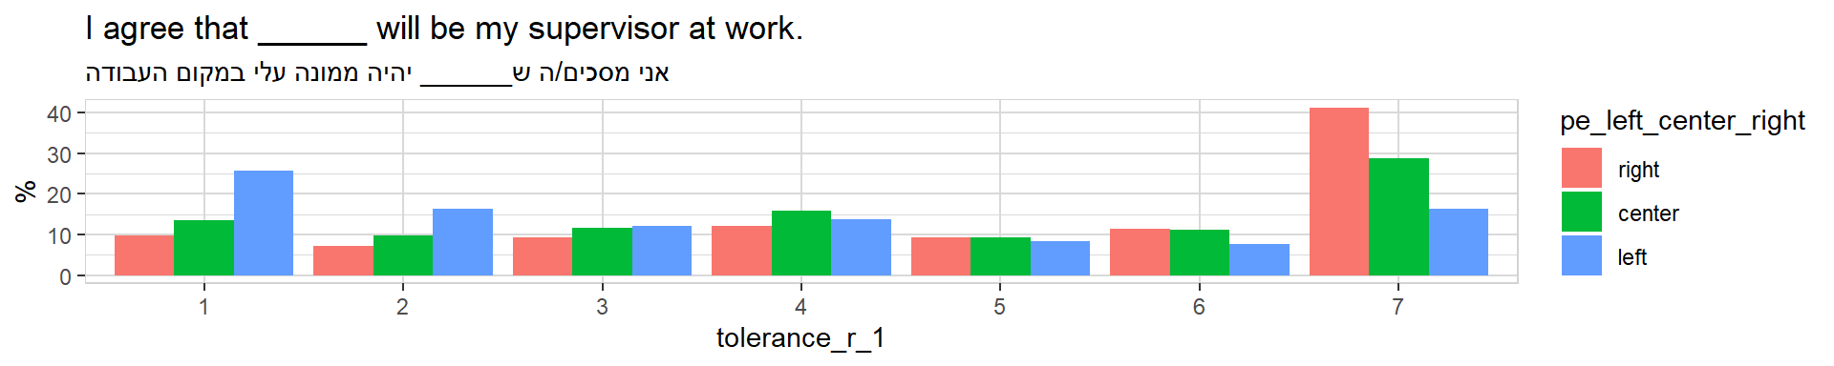
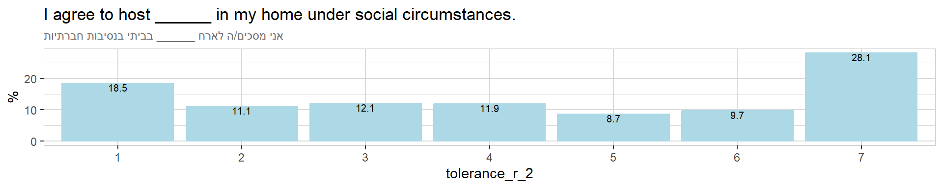
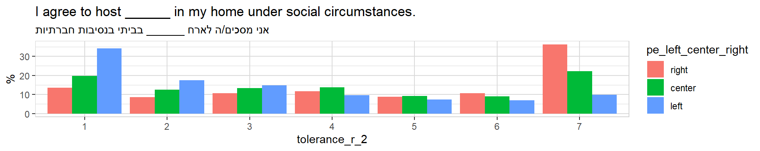
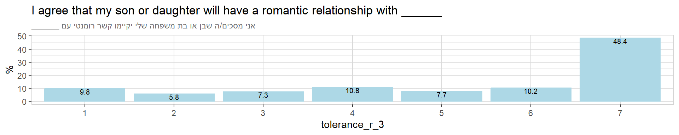
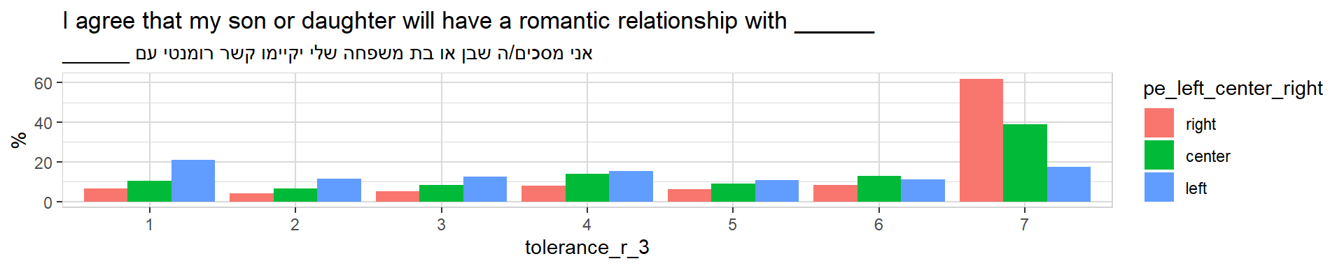
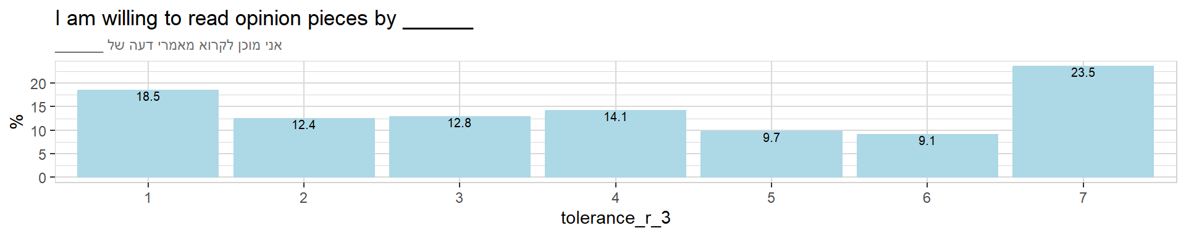
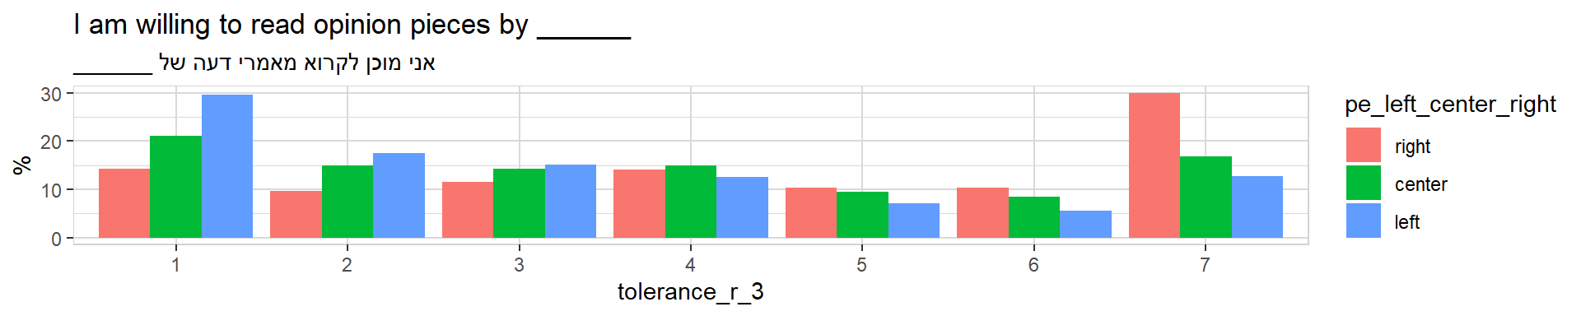

Political Exclusion
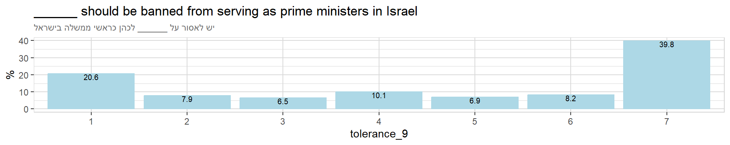
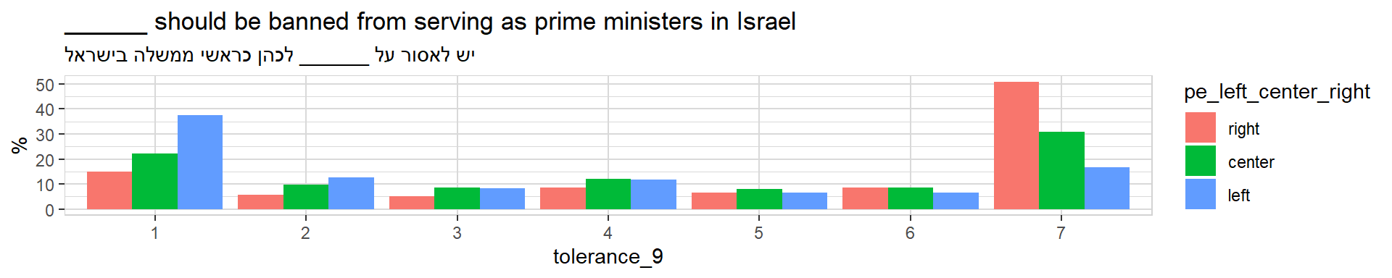
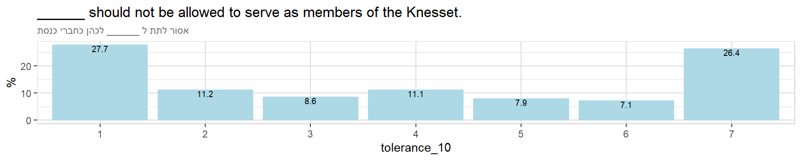
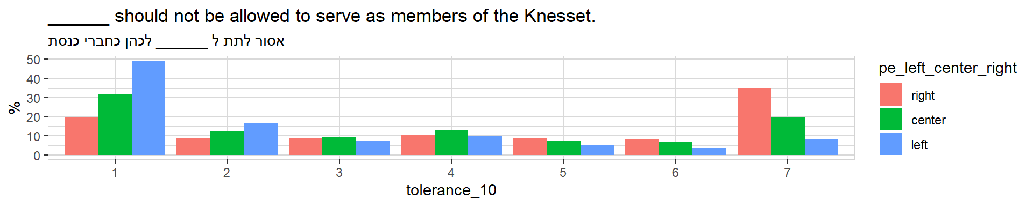
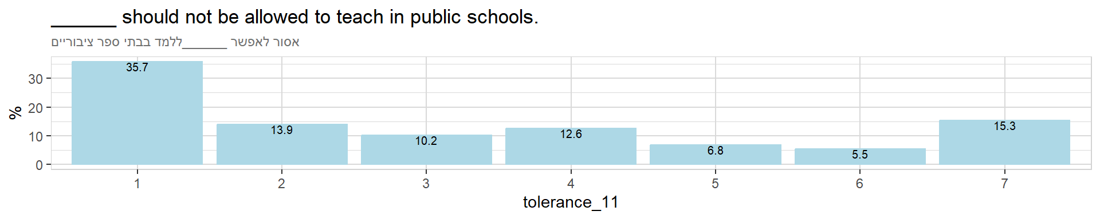
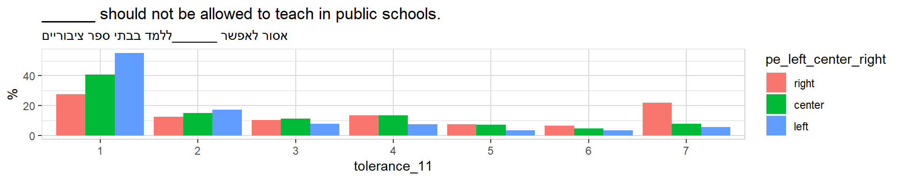
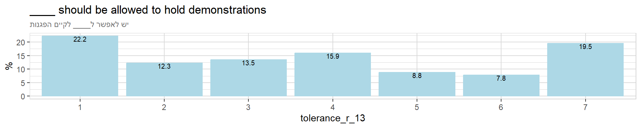
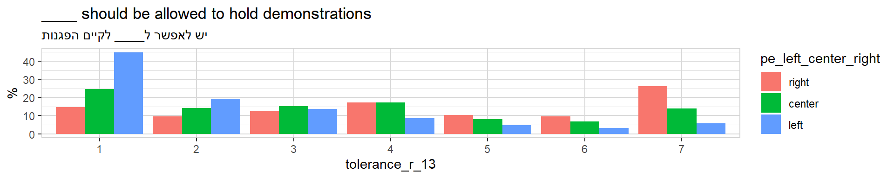
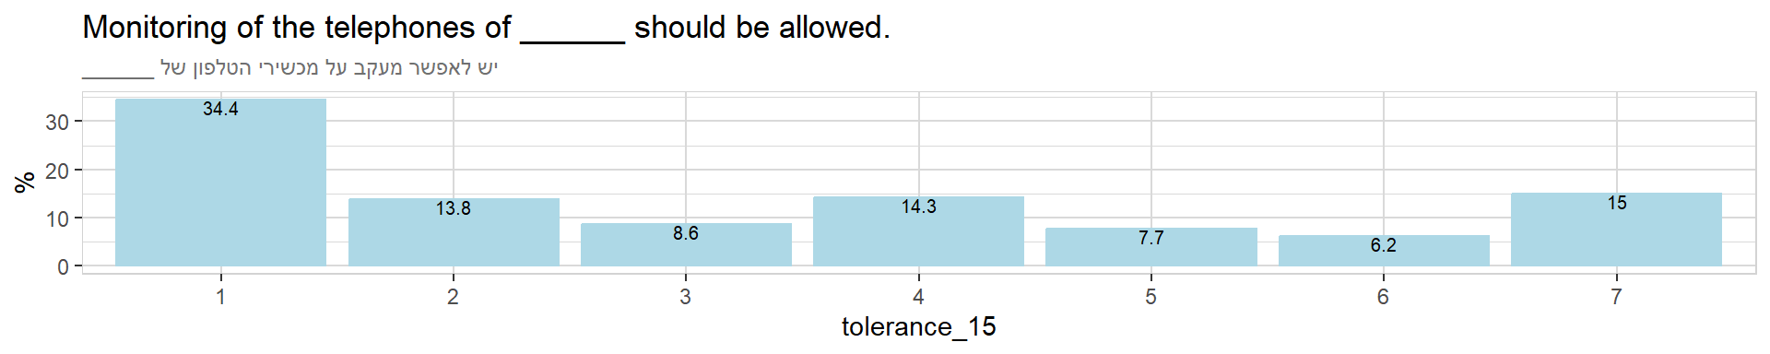
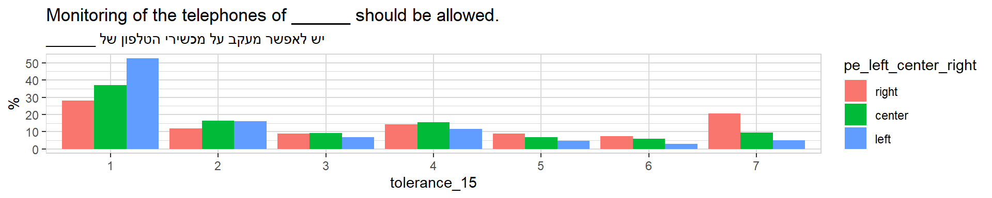
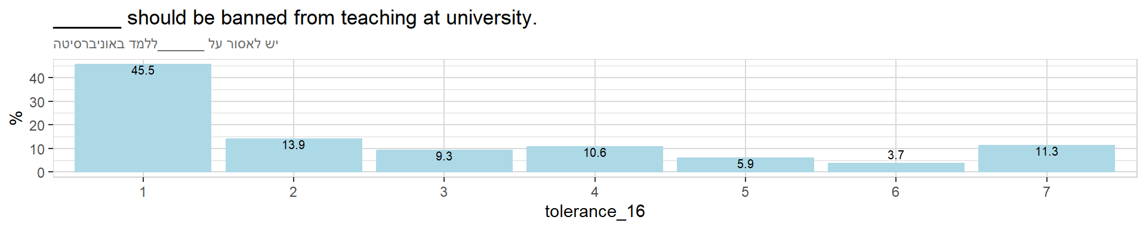
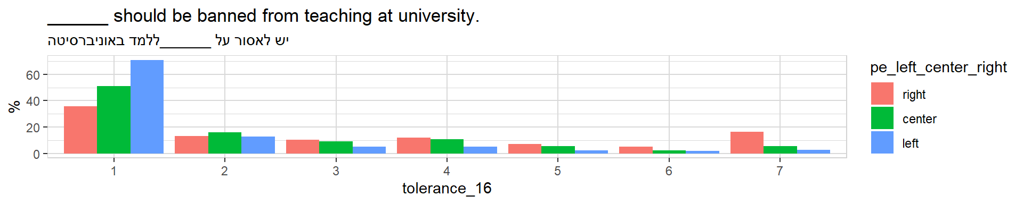
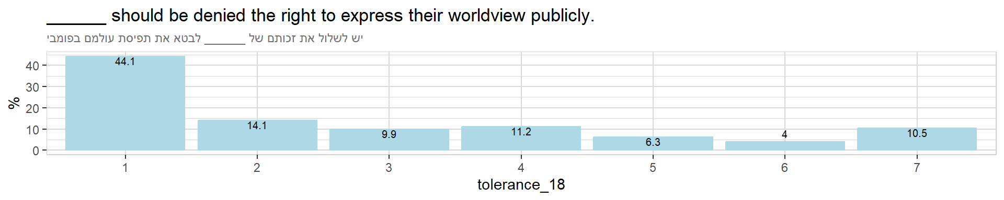
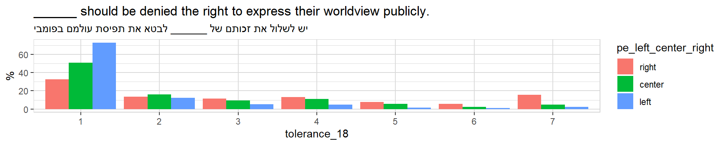
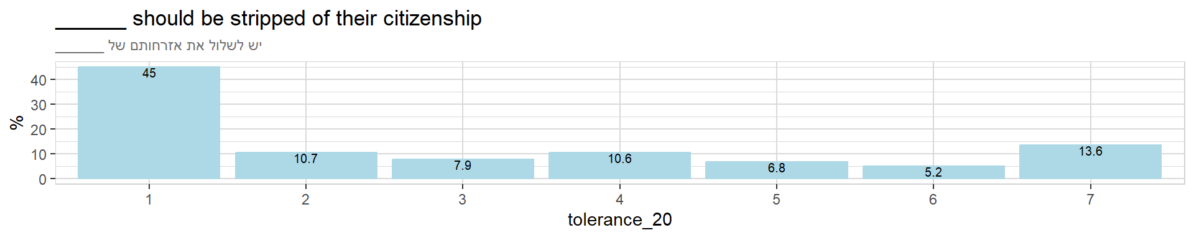
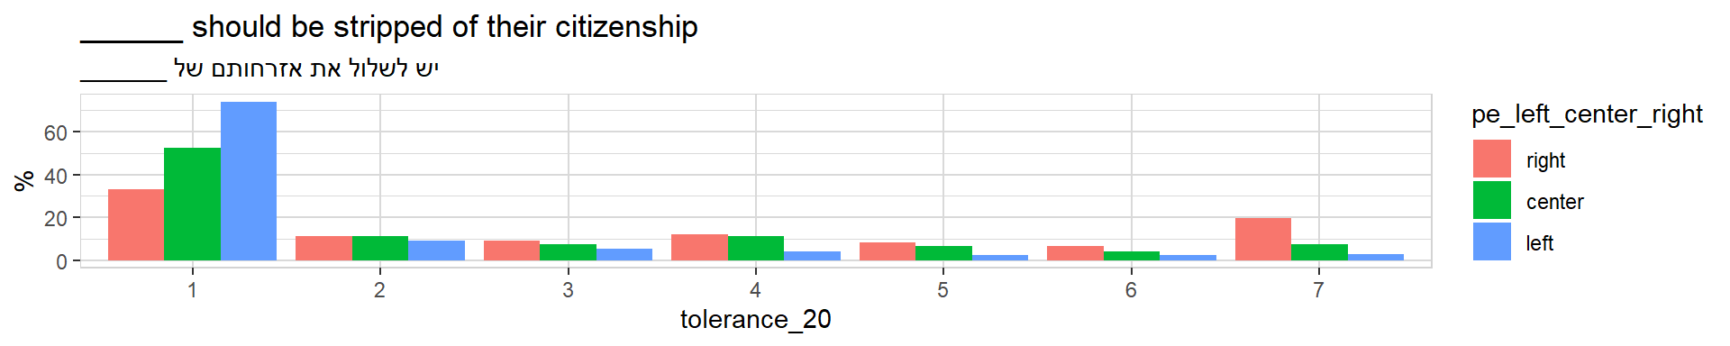

Control Variables
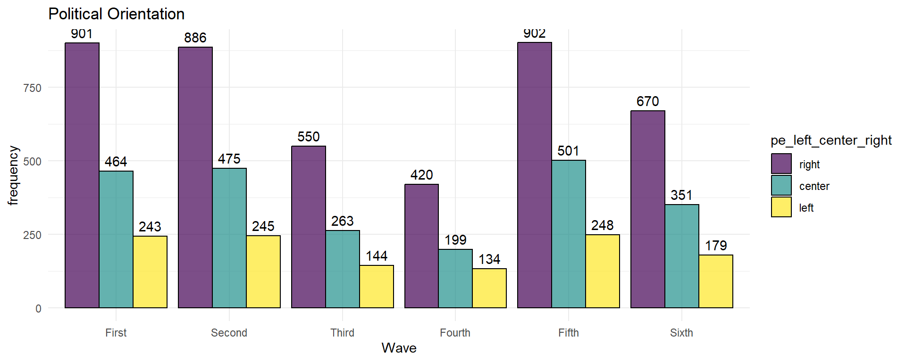
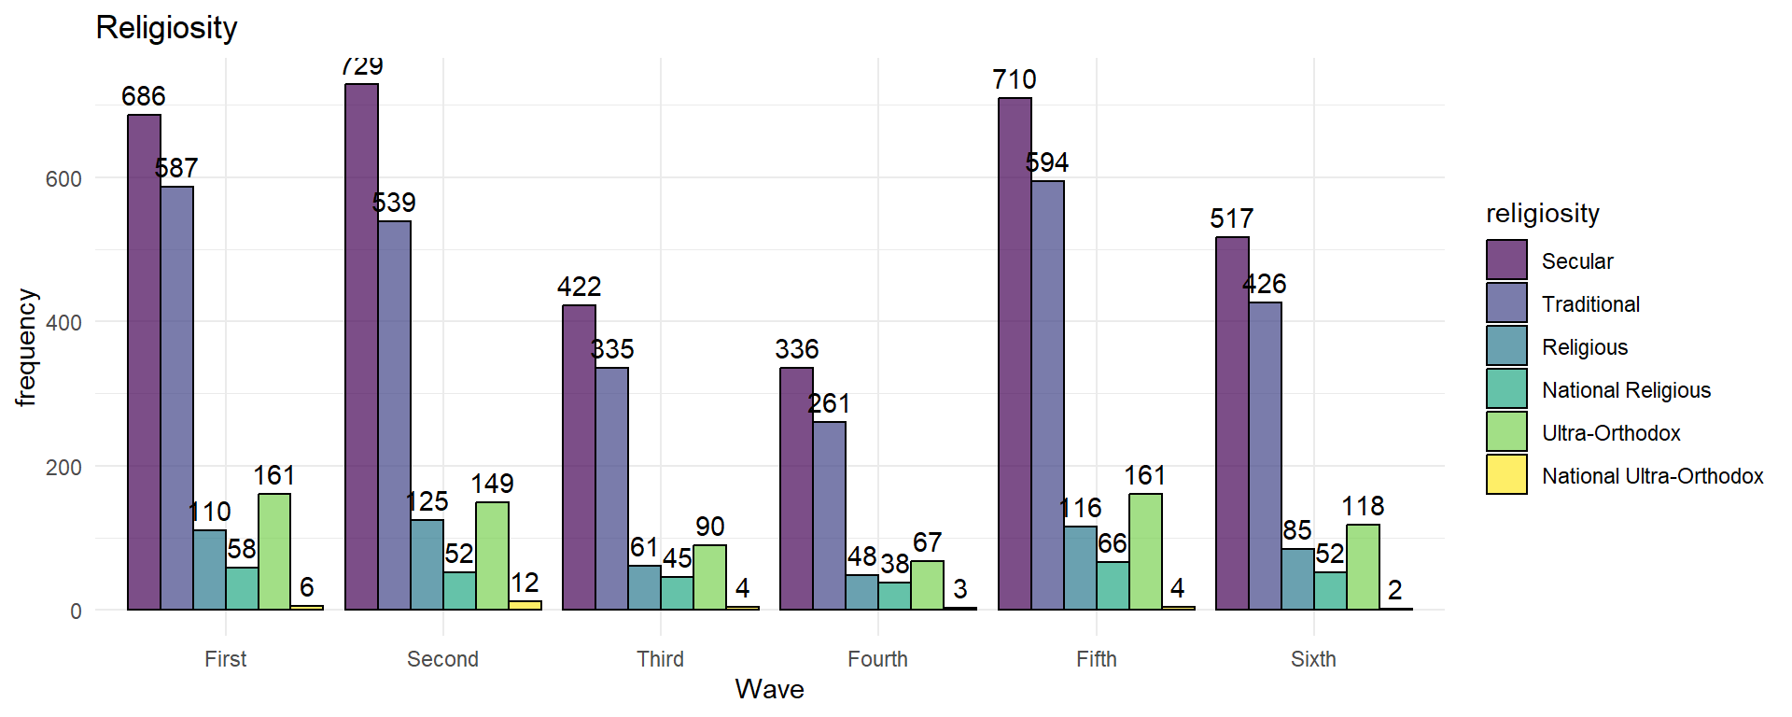
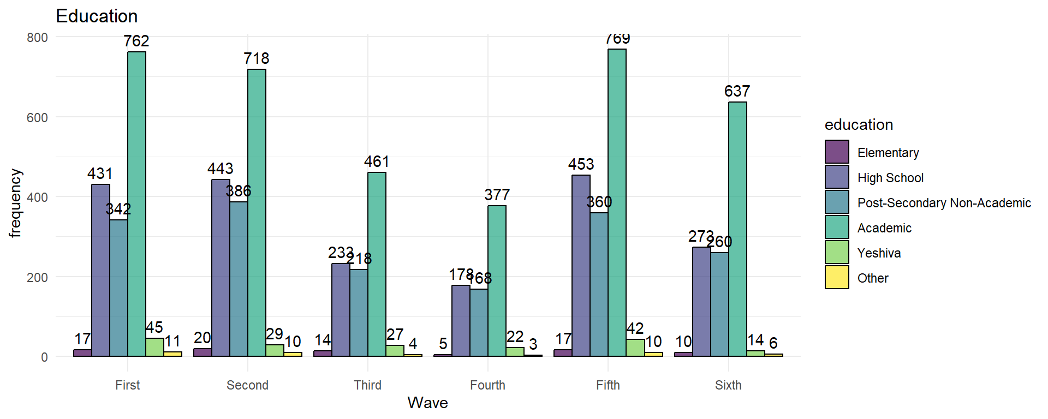
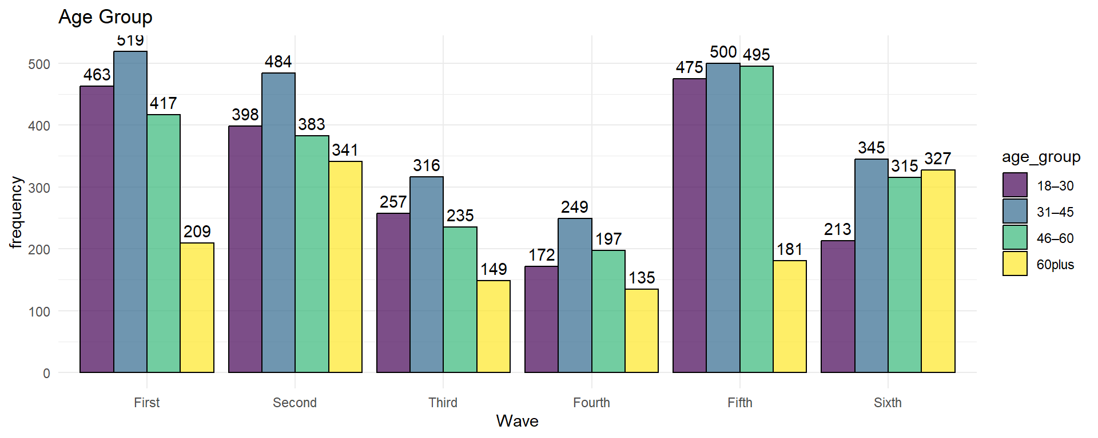
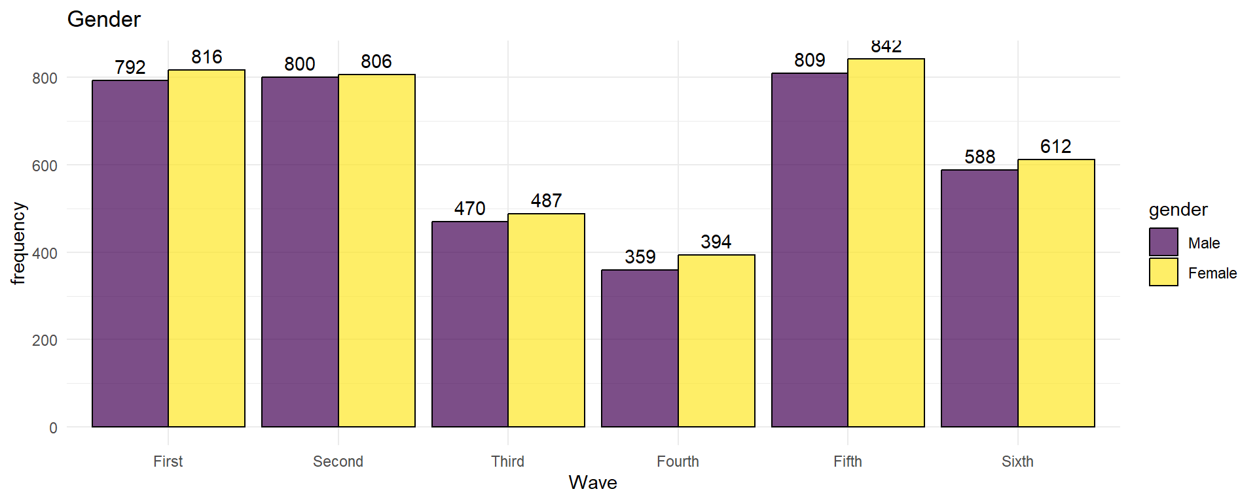

References
Backes, U. (2007). Meaning and forms of political extremism in past and present. Central European Political Studies Review, 9(4), 242–262. https://doi.org/10.22440/CEPSR.2007.9.4.art1
Berntzen, L. E. (2018). The anti-Islamic movement: Far right and liberal? [Doctoral dissertation, European University Institute]. https://doi.org/10.2870/693017
Bjørgo, T., & Braddock, K. (2022). Anti-government extremism: A new threat? Perspectives on Terrorism, 16(6), 2–8. https://www.jstor.org/stable/27185087
Carter, E. (2018). Right-wing extremism/radicalism: Reconstructing the concept. Journal of Political Ideologies, 23(2), 157–182. https://doi.org/10.1080/13569317.2018.1451227
Jackson, S. (2022). What is anti-government extremism? Perspectives on Terrorism, 16(6), 9–18. https://www.jstor.org/stable/27185088
Mudde, C. (1996). The war of words defining the extreme right party family. West European Politics, 19(2), 225–248. https://doi.org/10.1080/01402389608425132
Mudde, C. (2000). The ideology of the extreme right. Manchester University Press.
National Consortium for the Study of Terrorism and Responses to Terrorism (START). (2021). Profiles of Individual Radicalization in the United States (PIRUS) [Dataset]. University of Maryland. https://www.start.umd.edu/data-tools/profiles-individual-radicalization-united-states-pirus
Robinson, K., Malone, I., & Crenshaw, M. (2023). Countering far-right anti-government extremism in the United States. Terrorism and Counter-Terrorism Studies, 17(1), 73–87. https://doi.org/10.19165/LBEV6146
Teitelbaum, B. R. (2017). Lions of the north: Sounds of the new Nordic radical nationalism. Oxford University Press.
The White House. (2021, June 15). National strategy for countering domestic terrorism. https://www.whitehouse.gov/briefing-room/statements-releases/2021/06/15/fact-sheet-national-strategy-for-countering-domestic-terrorism/

